Advancing metrics for animal welfare and antibiotic use in sustainability assessments of diets
Lotta Rydhmer ^{a,}*, Elin Röös ^{b}
ª Department of Animal Biosciences, Swedish University of Agricultural Sciences, Box 7023, 750 07 Uppsala, Sweden
^{b} Department of Energy and Technology, Swedish University of Agricultural Sciences, Box 7013, 750 07 Uppsala, Sweden
* Corresponding author.
E-mail addresses: Lotta.Rydhmer@slu.se, Elin.Roos@slu.se

Abstract
Assessment of the sustainability of diets typically include the diet’s impact on the environment, using metrics such as the carbon, water and land footprint. However, there are other crucial sustainability aspects including animal welfare and antibiotic use that sustainability assessments usually neglect due to methodological challenges and lack of available data. This study contributes to the improvement of sustainability assessments of food systems by advancing metrics for animal welfare and antibiotic use. The proposed animal welfare indices reflect the number of animals affected per kilogram of animal product, the animals' cognitive ability to experience negative effects, and the quality of the production system, including disease frequency and space limitations. The proposed antibiotic use indicator acts as a proxy for the risk of bacteria developing resistance to antibiotics that threatens health of humans and animals. It was developed based on national sales data, adjusted for species-specific differences. The animal welfare indices and the antibiotic use indicator were applied to a range of animal products commonly consumed in a set of European countries, revealing substantial variations in animal welfare loss and antibiotic use across species and production systems. For example, rabbit and chicken production showed high welfare loss per kilogram of meat due to the number of animals affected and the relatively poor conditions in intensive livestock systems. Meat from cattle and wild-caught species had lower welfare loss (i.e. favourable) per kilogram, attributed to the larger body mass of these animals and less suffering in production. The metrics developed here offer a much needed tool for evaluating trade-offs between animal welfare, antibiotic use, and environmental sustainability in food production.
Keywords: Livestock sustainability, antimicrobial resistance, food ethics, trade-offs, animal production impacts

1. Introduction
Ideally, a broad sustainability assessment of food consumption should cover most of 17 UN sustainable development goals (SDGs). We contribute by developing metrics for two social aspects: animal welfare and antibiotic use in animal production. They are relevant since animal-sourced products form a large part of many diets; the global average consumption is estimated at 230 g per day and person (Miller et al., 2022). Most sustainability assessments focus on environmental impact using metrics for carbon, water and land footprint (Harrison et al., 2022). Assessments that include social aspects often focus on human health, such as diet related risk factors likely to affect mortality and disease burden (e.g. Springman et al., 2020) or nutritional quality (Yacoub Bach et al., 2023). Interest in broader assessments is growing (Hebinck et al., 2021; Lanzoni et al., 2023; Richter et al., 2024) and results from such assessments can support more holistic decisions by policymakers and consumers.
The World Organisation for Animal Health defines animal welfare as “the physical and mental state of an animal in relation to the conditions in which it lives and dies” (WOAH, 2024). Animal welfare is a key social sustainability aspect (Keeling, 2005; Vinnari and Vinnari, 2022) as food production directly and indirectly harms animals (Hampton et al., 2021). Hence it is highly relevant to include animal welfare in sustainability assessments of diets. Though not explicitly mentioned in the SDGs, improvements in animal welfare align with the SDG (Keeling et al., 2019; WellBeing International, 2022). National animal welfare laws, industry programs and certification schemes differ in ambition across European countries and production systems (More et al., 2021). EU laws (EU Council, 1998) reflect current animal welfare norms, but 84% of the Eurobarometer respondents support stronger protection of farmed animals (EU, 2023). Still, animal welfare remains largely absent from sustainability assessments (Vinnari and Vinnari, 2022). Most of the few attempts to include animal welfare in sustainability assessments have been rather simplistic, such as using share of organic production (Hebinck et al., 2021), and limited to a rather low number of animal species and production systems (Scherer et al., 2019).
Antibiotic resistance is another key social sustainability aspect. Misuse and overuse of antibiotics in animals and releases from animal production sites contribute to drug-resistant infections (UNEP, 2023) and threatens human and animal health (Aslam et al., 2024). Thus, the fight against antibiotic resistance is closely linked to SDG3 Good health and well-being and SDG 12 Responsible consumption and production (WHO, 2020). In 2019, 1.27 million global human deaths were directly caused by antibiotic resistant bacteria and the number of deaths associated with antibiotic resistance was almost four times higher (Murray et al., 2022). In Europe (WHO European region; 53 countries), 541,000 deaths were associated with antibiotic resistance (Mestrovic et al., 2022). Antibiotics (used against bacteria) and other antimicrobials are used to cure and to prevent infections in humans and animals, and in some countries antibiotics are also used for farm animal growth promotion. All antibiotic use increases the risk of bacteria developing resistance. Though resistance occurs naturally, it is accelerated by the use of antibiotics. The EU’s Farm to Fork strategy (EC, 2020) links antimicrobial resistance to excessive and inappropriate use in animal and human healthcare. The EU commission therefore takes actions to avoid overuse and to reduce overall EU sales of antimicrobials for farmed animals and in aquaculture, but a greater volume of antimicrobials is still sold to treat disease in food-producing animals than in humans (EEA, 2024).
Animal welfare and antibiotic use are related in several ways. According to EU’s Farm to Fork Strategy (EC, 2020) “Better animal welfare improves animal health and food quality, reduces the need for medication”. Furthermore, animal welfare can contribute to addressing environmental challenges (UN Environment Assembly, 2022). However, there are not only synergies, but also goal conflicts between animal welfare, antibiotic use and environmental impact (Bartlett et al., 2024). For example, exchanging beef from extensive production systems for pork and chicken meat from intensive production systems could reduce the climate impact of a diet, but may involve trade-offs with animal welfare and antibiotic use. Therefore, it is important to include animal welfare and antibiotic use together with environmental impacts in diet assessments.
Diets vary across regions in animal/plant ratios and product origins. We focus on European diets, where consumption of animal-sourced products is higher than the global average (Miller et al., 2022). European consumers eat animal-sourced food from several countries (i.e. domestic and imported food), but mostly from within Europe (Schwarzmueller and Kastner, 2022). Ideally, diet assessments use many metrics and data from many representative production units in all production systems contributing to the diets. However, no open database covers all relevant species, countries and production systems. Data on national antibiotic use for animals exist (ESVAC, 2023), but not by species. Primary data could be collected from representative production sites, for example by collecting antibiotic prescriptions on farms. Animal welfare data could be gathered via Welfare Quality® protocols (Blokhuis et al., 2013), but only for pig, cattle and poultry. When the aim is to evaluate total consumption of all foods in a diet including a wide range of animal products, such large-scale field data collection is not feasible for practical and economic reasons. Despite limited data availability, incorporating metrics for animal welfare and antibiotic use into sustainability assessments is both valid and valuable, contributing meaningfully to the advancement of scientific methodologies in this underdeveloped field. It can be done based on national databases, scientific studies and reports of agricultural organizations and authorities.
Existing animal welfare indices for sustainability assessments of diets (Scherer et al., 2018) include only six species, the indicator for animals’ moral value is based on scarce data, the indicator for life quality is based only on space allowance and production animals’ parents are not included. No indicator for antibiotic use in animal production has been used for sustainability assessments of diets. Our aim was to further develop methods for including animal welfare and antibiotic use alongside environmental indicators. This study introduces a novel indicator for antibiotic use applicable to specific food products, and advances animal welfare indices building on Scherer et al. (2018), covering more species and production systems (including parent animals) and an alternative way of taking animals’ cognitive ability into account.
To guide more sustainable food consumption, different diets must be compared in a holistic way, taking several issues into account (Hebink et al., 2021; Richter et al., 2024). Public discourse often isolates issues like climate impact, animal welfare and antibiotic resistance into separate debates. Our research question was: How can diet sustainability assessments be developed to evaluate and reveal synergies and goal conflicts between animal welfare, antibiotic use and environmental impact? We answer that question by proposing the following metrics:
- a set of indices to capture animal welfare issues, based on number of animals needed to produce 1 kg of animal product, animal suffering in the production system and different species’ ability to perceive negative effects of being used by humans
- an indicator for antibiotic use, based on national amounts of antibiotics sold for animals and estimated distribution over animal species and total biomass of different species in different countries
We illustrate these metrics using dietary patterns from three European countries, and include impact assessments to identify trade-offs (see supplementary material). To ensure transparency, all input data and calculations are available as spreadsheets, allowing users to adapt metrics or update calculations with more specific data.

2. Background and theory

2.1 Ethical perspectives on animal sourced food
Animal rights and the extent to which using animals for food production can be morally justified is a complex issue that has been discussed extensively by philosophers. Several perspectives exist where the utilitarian view supports humans using other animals provided their interests are given the same consideration as human interests, and the use enhances overall wellbeing (Singer 1975). The animal rights view considers any use, abuse or killing of sentient animals morally wrong and such use should therefore be heavily decreased or abolished (Regan, 1985). Vinnari and Vinnari (2022) presents a framework reflecting these perspectives and describe a potential shift from no rights for animals via simple rights to fundamental rights for animals. Our work on animal welfare indices fits within ‘simple rights’ on the scale of Vinnari and Vinnari (2022), where humans’ use of animals is acceptable “but subject to welfare considerations” and “suffering inflicted on animals should be minimized”. From a utilitarian point of view, an individual animal’s impaired welfare may be outweighed by other factors beneficial for humans, such as lower climate impact of food consumption. If a large number of animals severely suffer in food production, the beneficial impacts of this animal-sourced food consumption on humans must be large to outweigh the suffering of animals (Palmer and Sandøe, 2011). Ideally, consideration should not be limited to the production animals themselves, but should include all animals in the system, e.g. parents of production animals and wild animals affected by feed production (Vinnari and Vinnari, 2022).
From an animal rights perspective, the animal is an individual worthy of respect in its own right since it has an interest in continuing to live (Francione, 2010). This view excludes consumption of animal-sourced food and animal welfare indicators then becomes obsolete. The animal welfare indicators in our work are developed with an underlying assumption that humans have the right to use and kill animals for food production. With an animal integrity perspective, the animal is not defined through its function as source of food for humans, it is regarded as a sentient being experiencing its own life (Röcklinsberg et al., 2014). With respect for animals’ integrity, what is ethically acceptable can therefore not be based only on utilitarian calculations of maximum benefit; number of animals needed (i.e. number of lives) for a diet also matters (Röcklinsberg et al., 2014). Globally, 200 billion farmed animals (birds, mammals and finfishes) were slaughtered for food production in 2019 (Mood et al., 2023). Our work is based on a utilitarian view, which is why we combine animal welfare, use of antibiotics and climate impact in the diet assessment to show synergies and trade-offs for humans as well as animals (see the supplementary material, SMX). However, we also include an animal integrity perspective which explains why we take number of involved animals into account in the animal welfare indices.

2.2 Animal welfare challenges
Harrison, in the book Animal Machines (1964), stated that animals in food production were considered as inanimate machines rather than living individuals. The Brambell Committee was set up by the British government as a consequence of Harrison’s book (Broom, 2011). In the Brambell report from 1965, the ‘five freedoms’ were introduced. Today, the five freedoms are known as freedom from hunger and thirst, freedom from discomfort, freedom from pain, injury or disease, freedom to express normal behaviour and freedom from fear and distress (FAWC, 2009). The term ‘animal welfare’ was used in the 1970, but not defined and not acknowledged as a scientific subject. Research on motivation systems by ethologists and psychologists at the time described that animals have needs and become frustrated when these needs are not fulfilled (Broom, 2011). Hughes (1981) proposed that the term animal welfare meant that the animal is in harmony with nature, or with its environment. Broom (1986) developed the concept into something measurable: “The welfare of an individual is its state as regards its attempts to cope with its environment”. WOAH (2024) specify that this ‘state’ is both physical and mental, and that it is in relation to the conditions in which the animal lives and dies (WOAH, 2024). In our animal welfare indices, the animal’s ability to perceive effects of being used by humans mirrors the animal’s state and the quality of the production system mirrors the animal’s environment or condition.
There are several major animal welfare issues in food production, often related to frequent diseases and injuries and restricted area available for farm animals, and to catching or shooting wild animals (Hampton et al., 2021). Death is not necessarily regarded as an animal welfare issue in itself (depending on ethical perspective), but mortality on farm is often preceded by a period of disease or stress and thus indicate low welfare. Animals’ ability to perform behaviours that they are strongly motivated to perform is crucial for animal welfare (WOAH, 2024). In intensive production systems, animals are often kept in an environment where there is not enough room for performing those behaviours, such as rooting or grazing. High stocking density does not only hinder animals’ movements, it also increases the risk of aggressive interactions and spreading of infections in the group (Maes et al., 2020).
Animals like salmon, pigs and chickens are raised to be slaughtered at a given time, usually before sexual maturity. Lying hens and dairy cows are culled as adults. Wild animals are killed when shot or when caught. The whole slaughter process, from animal collection and transport to death, may cause fear and pain (e.g. Tomás et al., 2024). The duration of this process varies between production systems, with a range from less than a minute (for shot animals) to more than a day (ECA, 2023).
Domesticated animals are selected for high production levels (growth, milk, eggs etc). This has led to lower climate impact per kg of product, e.g. per kg of meat or milk produced (Naranjo et al., 2020; Thoma et al., 2024) but also some unfavourable genetic changes in traits important for animal welfare. Two well-known examples are high selection pressure on milk yield that increases the risk of mastitis (udder inflammation) and high selection pressure on growth rate that increases the risk of leg problems in several species (Rauw et al., 1998). Therefore, resistance to mastitis and strong legs and other traits important for animal welfare are included in the breeding goals alongside with the production traits. However, considerable animal welfare problems related to e.g. diseases and mortality on farm still prevail. A metric covering disease frequency, mortality rate, stocking density and duration of the slaughter process has the potential to reveal differences in animal welfare level between different production systems for different types of animals.

2.3 Assessing animal welfare per kg of product
European consumers eat food products from farmed as well as wild animals. Wild animals can, of course, suffer from diseases and injuries during their whole lifetime. However, our animal welfare indices describe the part of an animal’s life that humans are directly in charge of. For a pig or a salmon in aquaculture, the evaluated time period starts when the animal is born and continues until the animal is dead. For wild animals, the evaluated period starts with shouting or catching and continues until the animal is dead.
Assessments of specific food products can go to considerable depth and breadths. For example, Zira et al. (2021) included animal welfare in a life cycle sustainability assessment (LCSA) of different pig production systems using more than twenty indicators relevant for pig production, e.g. pigs’ access to daylight and frequency of pigs with injured tails. For diet assessments, a method that can be used across different animal species (e.g. beef, chicken, blue mussels), accounting also for different species’ cognitive ability, is however needed. Scherer et al. (2018) developed a framework for integrating animal welfare in LCSA across species. They proposed three different indicators of animal welfare loss: animal life years suffered (ALYS), loss of animal lives (AL), and loss of morally adjusted animal lives (MAL). In MAL, Scherer et al. (2018) took animals’ moral value (denoting “intelligence and self-awareness” of different species) into account.
Richter et al. (2024) have reviewed the literature, including the work by Scherer et al., 2018, and present a conceptual framework for animal welfare assessments of foods. Our animal welfare indices are (as far as we know) the first indices presented with clear references, step by step, to the framework of Richter et al. (2024). We summarize our approach for developing the animal welfare indices according to their framework here, and in more detail in SM6. The framework by Richter et al. (2024) is structured in five steps: 1. Type of assessment; 2. Inclusion and identification of animals; 3. Animal welfare components; 4. Indicators; 5. Aggregation.
Step 1 in the framework of Richter et al. (2024) concerns the type of assessment and there are three types; ethical, risk and welfare assessments. The definitions of risk and welfare assessments overlap, and both evaluate the likelihood of a certain quality of life (Richter et al., 2024). Our assessment focuses on loss of welfare, i.e. negative impacts. In terms of included animals (Step 2), we include food-producing animals in agriculture and aquaculture as well as wild animals used for food production, but not wild animals indirectly affected by food production (e.g. fishes in fish meal fed to poultry). We assume that all animal species involved in food production have some capacity of sentience.
Step 3 in the framework of Richter et al. (2024) concerns animal welfare components. Our animal welfare indices cover all life stages for farmed animals, and the “salience of experiences” is considered by weighting indicators. Richter et al. (2024) has “consideration of life duration” as one of the animal welfare components in Step 3. ALYS (in this article and in Scherer et al., 2018) takes life duration into account, assuming that every day is a day suffered. This can be questioned for two reasons: Firstly, assume calves slaughtered at 6 or 7 months. If, for example, stocking density is very high the calves have suffered during their whole life, regardless of whether it was 6 or 7 months. Secondly, animals can experience both positive and negative emotions during life (although our indicators only describe welfare loss, i.e. negative animal welfare aspects) and shorter life duration might not be preferable from an animal welfare perspective.
Mortality on farm which is premature in relation to the expected age at slaughter is included in our indices but, in contrast to AL and MAL presented by Scherer et al. (2018), we did not include life fraction (slaughter age / life expectancy). Broom (2011) states that animal welfare is associated with the living animal’s attempts to cope with its environment and writes that “ethical issues about whether or not animals should be killed for human benefit are sometimes perceived to overlap with the concept of welfare but they do not”. Accordingly, we do not include deprived lifetime in the animal welfare concept. Not counting with life fraction reflects the perspective that if we accept that humans have the right to use and kill animals for food production, the lost lifetime has little relevance. For these reasons we wanted to construct an index that is not based on lifetime lost.
Step 4 in the framework of Richter et al. (2024) concerns the choice of indicators. The production system (i.e. the type of environment and management in which the animals are kept) leading to mortality, disease and impaired ability to perform natural behaviours is crucial to animal welfare. We use the term ‘suffering’ to describe the quality of the production system with regard to animal welfare; Scherer et al. (2018) called it ‘life quality’. Scherer et al. (2018) used only space allowance to capture this, and the indicator differed between species, e.g. days on pasture for dairy cattle and stocking density for chickens. We wanted to base the indices on a broader, but still feasible (in terms of data collection and comprehensiveness), description of the production system and used disease frequency, mortality on farm, lack of space and duration of slaughter process to describe “the conditions in which it [the animal] lives and dies” as stated by WOAH (2024). According to the framework of Richter et al. (2024), indicators can be resource-, animal- or management-based. In our indices, lack of space (including time on pasture) is resource-based, mortality and disease frequency are animal-based, and slaughter duration is management-based.
The final step (step 5) in the framework of Richter et al. (2024) concerns aggregation. We do a full aggregation into one overall score to enable the use of the indices in diet assessments. The aggregation is done taking species’ ‘welfare capacity’ and ‘valuation of affected animals’ into account, as asked for in the framework of Richter et al. (2024). For affected animals, we use the number of involved animals needed to produce a certain amount of animal product (e.g. 1 kg of beef), in accordance with Scherer et al. (2018). For welfare capacity, Scherer et al. (2018) used brain mass, number of total neurons or number of cortical neurons (depending on data availability) to determine the moral value relative to a human being. Paris et al. (2022) also used moral value to assess foods from different species and for species lacking data on neurons they used brain weight/body weight ratio. We wanted another way to describe different species’ ability to perceive negative effects of being used for food production, for several reasons. Firstly, although Herculano-Houzel (2012) use neuron numbers to predict animals’ ‘intelligence’, the correlation to “the physical and mental state of an animal” (in the animal welfare definition of WOAH) seems unclear. Secondly, data on number of neurons are not available for all species involved in European diets (Paris et al., 2022). Thirdly, we wanted to take the potential effects of age (e.g. a newly hatched chicken compared to an adult hen) and domestication (e.g. a pig compared to a wild boar) into account. Although the number of scientific studies on animals’ ability to feel pain, fear and distress is increasing (see Birch et al., 2021 for molluscs and Gibbons et al., 2022 for insects), comparable data for young and adult animals of all species included in European diets are still lacking. While waiting for such data, we defined animals’ ability to perceive negative effects of being used by humans with a questionnaire to experts in animal science and veterinary medicine.
Three comprehensive sustainability assessments of diets were recently performed by Scherer et al. (2019), Paris et al. (2022) and Allenden et al. (2022). They used ALYS, AL and MAL developed by Scherer et al. (2018). Thus they were all based on only one indicator of animals’ life quality and a moral value calculated from scarce physiological data. Furthermore, the number of included species was limited, especially for wild animals.

2.4 Antibiotic resistance challenges
Antibiotics is a group of antimicrobials produced from moulds or made synthetically and used against bacteria. The aim of treating humans and animals with antibiotics is to kill bacteria or prevent bacteria from multiplication. The first antibiotics were used to treat humans with infections in the beginning of last century (Uddin et al., 2021). Fleming discovered that a fungus inhibited growth of staphylococci and isolated the active substance penicillin 1929. Flory and Chain managed to scale up the production and penicillin treatment was implemented in practice 1945. Already 1945, Fleming, when receiving the Nobel prize, warned that overuse of antibiotics could result in selection for resistant bacteria. The fact that most of the antibiotics used today are still variants of those developed during the glorified era of antibiotic discovery (1950-1970) increases the health threat of antibiotics resistance (Uddin et al., 2021).
Antibiotics are needed in both human and veterinary medicine to cure infections and to prevent infections when surgery and cancer treatments are performed. Eating food products from animals treated with antibiotics do not cause direct health problems among consumers – use of antibiotics in food production is a social sustainability aspect because it increases resistance to antibiotics, thereby threatening the health and welfare of humans and animals. In general, problems with antibiotic resistance get worse the more antibiotics that are used. Unlike animals, bacteria have the capacity to exchange genetic material between each other within generation. When, for example, manure is used as fertilizer on the field, bacteria that have achieved resistance due to mutations can transfer the resistance genes to other species of bacteria in the soil (Lima et al., 2020). The magnitude of this transfer is, however, at large unknown.
Antibiotics is used in animal production for three reasons:
- To cure infected animals
- To prevent animals from being infected
- To promote higher production levels (often higher growth rate), so called ‘growth-promotors’
Regular use of antibiotics by routine for prevention and as growth-promotors can mask issues related to hygiene, stocking density and inappropriate management which can decrease animal welfare. A completely antibiotic-free food production is, however, not acceptable from an animal welfare perspective since sick animals shall be treated. The goal is a prudent, medically rational use of antibiotics so that specific antibiotics continue to offer successful treatments against specific infections in humans and animals, and so that the ratio of resistant bacteria species does not further increase (Magnusson et al., 2019). The use of antibiotics as growth promotors is prohibited in the EU since 2006 (EC, 2005) and the use of antibiotics for regular disease prevention is prohibited in the EU since January 2022 (EU, 2019a; EU, 2019b).
2.5 Assessing use of antibiotics per kg of product
The actual amount of antibiotics used for animals in food production is not known and therefore the country-wise monitoring performed by European Surveillance of Veterinary Antimicrobial Consumption (ESVAC) was based on sold amounts (ESVAC, 2023). Since the population of animals varies between countries, the use of antibiotics has been reported per total biomass. Corresponding data are available for some countries outside Europe and missing for others. No country reports data on sales per production system in a systematic way and so far, only a few countries report data on sales per species (e.g. UK (UK-VARSS, 2022) and Denmark (DANMAP, 2021) for some species).
The amount of prescribed antibiotics for an animal depends on its weight. Species differ in bodyweight and the proportion of different livestock species varies among European countries. Comparisons between countries should thus be made in relation to biomass. National data on total biomass, recorded in Population Corrected Units (PCU) have been presented by ESVAC (2023). PCU is a theoretical unit developed by the European Medicines Agency (EMA). It takes into account that it is more common to treat young than adult animals and that young animals are lighter than adult animals. The total biomass for each country is calculated as number of animals of different species in the country (reported yearly to national authorities) and an assumed body weight at treatment for each species (ESVAC, 2023).
The need for antibiotic treatments differs between production systems and species. Rabbits, for example, are highly susceptible to bacterial infections (Peng et al., 2025). Since low use of antibiotics is easier to achieve for some species than others, the proportion of species in animal production matters for the national total sales. As stated by the European Public Health Alliance: “Most of the differences between countries are in fact likely due to large differences in usage in each species” (Nunan, 2022). For each country, our antibiotic use indicator takes into account the sold amount of antibiotics, the total biomass in population corrected units, the proportion of species in that biomass and how ‘easy’ it is to keep the amount of antibiotics low for different species.

3. Methods

The study consists of several parts. First, we develop three animal welfare indices based on the framework by Richter et al. (2024), developing and expanding the work by Scherer et al. (2018), and populate them with literature data across various livestock species and countries (Section 3.1). Second, we propose a new indicator to measure antibiotic use, using official data from European livestock systems (Section 3.2). In the supplementary material (SM3a), we show how an animal welfare index and an antibiotic use indicator can be combined with existing data on climate impact, to demonstrate how diets can be assessed using our metrics.

The animal welfare indices include indicators for affected animals, animals' cognitive ability and suffering caused by the production system. The antibiotic use indicator is a species specific adjustment of amount of sold antibiotics per animal biomass in each country. Together, the animal welfare indices and the antibiotic use indicator are called ‘metrics’. The functional unit for these metrics is kg animal sourced food.

3.1 Animal welfare indices
Animal welfare is defined as “the physical and mental state of an animal in relation to the conditions in which it lives and dies” (WOAH, 2024), taking the five freedoms (FAWC, 2009) into consideration. We present results for three indices: 1) a new index, Perception Adjusted Animal Lives Affected (PAALA), 2) Animal Life Years Suffered (ALYS) as defined by Scherer et al. (2018) but with an extended ‘life quality’ component here called ‘suffering’, and 3) Perception Adjusted ALYS (PAALYS). PAALA and PAALYS consider 1) the number of involved animals to produce 1 kg of raw commodity (e.g. kg of bone-free meat, eggs, peeled shrimps or milk, 2) these animals’ ability to perceive negative effects of being used by humans, and 3) a judgement of the quality of the production system expressed as the suffering that animals are exposed to in the typical production system. Thus ‘ability’ describes the animal and ‘suffering’ describes the production system. ALYS considers the number of involved animals and suffering, but not animals’ ability. The indices reflect the whole life for farmed animals. For wild animals, only the part of life directly related to food production, i.e. shooting or catching, transport and slaughter, is included.
The indices are calculated as follows (variables are further explained in sections 3.1.1-3.1.3):
PAALA = number affected x ability x suffering_including_slaughter x 100
ALYS = number affected x ([life duration – slaughter duration] x suffering_excluding_slaughter + slaughter duration)
PAALYS = ability x ALYS
where
number affected is number of animals involved to produce 1 kg food
ability is the animals’ ability to perceive negative effects of being used by humans
suffering describes the quality of the production system, either including or excluding the slaughter process
life and slaughter durations are animals’ life length and length of slaughter process
PAALA is multiplied with 100 to increase the readability of the index value. Data for number affected, suffering, life duration and slaughter duration come from the literature. Data for ability come from a questionnaire to experts in animal science and veterinary medicine.
The animal welfare index values for production animals and their parents were added to get the animal welfare index value per kg product for beef from suckler production and for sheep, pig and chicken meat. For calves from dairy cows, all welfare impact was allocated to the cow and its milk, and parent is thus not applicable. For other animals, the impact of parents was assumed to be negligible due to the low number of parents needed (salmon and insects) or due to similarity to production animals (rabbit and laying hen), and thus not included as a separate group of animals. Horses were not regarded as production or parent animals since commercial horse meat production is very limited and horse parents were therefore not included as a separate group of animals. For eggs, male chickens discarded at hatching were included as a sepaate group of animals in addition to laying hens.
The indices are presented for major animal products (from cattle, pig, poultry, sheep, rabbit, horse, farmed salmon, blue mussel, wild fish, shrimp, octopus, wild ruminants, wild boar, wild rabbit, mealworm and honey bee) as consumed in nine European countries (France, Germany, Greece, Hungary, Ireland, Italy, Poland, Spain and Sweden, see SM1). Hence, we developed animal welfare indices for livestock production in these countries. Indices were also developed for meat, milk and eggs from Denmark and the Netherlands, and lamb meat from the United Kingdom (UK) and New Zealand, as the nine consumption countries import substantial amounts of these products. Indices were also developed for insects like mealworms and honeybees and for wild ruminants, boars, rabbits, and for blue foods, i.e. animal products produced or caught in waters (including farmed salmon from Norway), wild fish, octopus, shrimp and blue mussel.

3.1.1 Number of animals affected
The number of affected animals to produce 1 kg of animal product for different species in the nine countries was based on Röös et al., 2025. Number of animals (lives) per functional unit can be an ethical issue but it is not necessarily an animal welfare issue per se. Thus we chose to reduce the importance of this factor at its extremes, and used an arbitrary minimum number of 0.0001 animal per kg which resulted in an increased number affected for the dairy cow. We also chose to reduce the importance of number affected by adjusting the number for the smallest animals; the number for blue mussels and shrimps was divided with 10 and the number for honeybees and meal worms was divided with 100. Without these arbitrary adjustments (that reflect our ethical view), the animal welfare index value for food from the smallest animals would be very unfavourable even with a perfect production system, and very favourable for milk even with the worst possible production system. The adjustments of numbers of animals were done for all three animal welfare indices.

3.1.2 Ability
The involved animals’ ability to perceive negative effects of being used by humans is a relative value defined with input from a group of 15 experts in animal science and veterinary medicine at the Faculty of Veterinary Medicine and Animal Science at the Swedish University of Agricultural Sciences. They were asked to distribute 110,000 points over 11 groups of species (e.g. poultry and wild fowls, ruminants including game, and mealworms and honeybees) in a questionnaire (SM4). The total of 110,000 was chosen to facilitate the distribution of points to species for which we assumed the respondents would give very few points, as compared to the number of points they would give to large mammals. The average points given by the 15 respondents were divided by 110,000 to get a relative value. A value of 0 would mean that animals of this species have no ability to perceive negative effects of being used by humans. The questionnaire also included questions on domesticated and wild animals’ and young and adult animals’ ability (within species) to perceive negative effects of being used by humans. Again, relative values were used. The average points were reported and discussed with the respondents at a workshop, and they got the possibility to review their points based on that discussion. The questionnaire including the answers from the experts is available in SM4.

3.1.3 Suffering
The suffering in the production system is described based on i) mortality and ii) disease frequency and iii) lack of space in relation to body size and iv) duration of the slaughter process. These indicators were chosen because they are associated with four of the five freedoms defined by FAWC (2009), i.e. freedom from discomfort; freedom from pain, injury and disease; freedom to express normal behaviour and freedom from fear and distress (freedom from hunger and thirst is not covered by suffering). They were also chosen for being relevant to many species and for their ‘feasibility’, i.e. comparable data could be found for many species. We calculated the suffering part of the indices as:
suffering = (2 x mortality + 2 x disease frequency + 2 x lack of space) + slaughter duration
For ALYS and PAALYS we normalised mortality, disease frequency and lack of space between 0 (best) to 1 (worst) to be consistent with the definition of ALYS in Scherer et al. (2018). Equal weight on mortality, disease frequency and lack of space and less weight on slaughter duration was based on Zira et al. (2020) where experts gave equal weight to “free from fear, pain and injuries” (reflected by mortality), “good animal health” (reflected by disease frequency), “animal friendly housing” plus “possibility to express natural behaviour” (reflected by lack of space) and halved weight to animal friendly management (reflected by slaughter duration). When including suffering in ALYS and PAALYS we omitted the slaughter duration (as it is included in these indices explicitly) to avoid double counting. Average values for mortality and disease frequency and slaughter duration for production systems in different countries were collected from scientific and ‘grey’ literature (references in SM5).
Mortality describes the ratio of animals dying on farm (i.e. before slaughter). Disease frequency reflects the ratio of animals diseased or injured at least once before slaughter. For animals living longer than one year (e.g. dairy cows), it reflects the number of animals diseased or injured at least once per year. Wild animals were assumed to live a life independent of humans and enter the food production system at the end of their life, i.e. when shot or caught (fishing). Mortality and disease frequency were therefore set to zero for wild animals. Mortality and disease frequency were also set to zero for honeybees and meal worms due to lack of data.
Lack of space (describing stocking density) was calculated based on the size of the animal (animal area = body length x body width at the largest place of the body) and the available minimum area per animal according to EU’s animal welfare law or the national law in the country where the production takes place. If the bodies of all animals in a pen fill up one third of the pen size the lack of space is 0.33 and if they fill up two thirds the lack of space is 0.67. This was done for several phases of the animals’ lifetime so that the relative lack of space describes the average of all days in life. Days on pasture were regarded as days without space restriction (lack of space = 0); if an animal spends one third of its lifetime on pasture the relative lack of space value is only two thirds of the value for a corresponding animal spending all time indoors. For fish, relative space was based on volume (body length x body area at the largest place of the body). Wild animals have no lack of space. Lack of space was also set to 0 for meal worms and honeybees, due to lack of data and with the assumption that stocking density is not relevant for insects that form colonies. Furthermore, honeybees can leave the hive for most of the year.
Slaughter duration describes the average length of the slaughter process expressed as duration in hours divided by 24 hours. Slaughter duration includes catching or collecting animals on farm, loading, transport, loading off and lairage time on the slaughterhouse. Data on localisation of farms and slaughterhouses as well as average duration of slaughter process are scarce. The duration of transport from farm to slaughter plant was assumed based on frequencies of short (<8h), long (8-24) and very long (>24 h) journeys in EU 2017-2021 presented by ECA (2023) for intra-EU transports of horses, poultry, pigs, small ruminants and cattle. For wild animals killed by shooting, the slaughter process duration was set to one minute. Mealworms were assumed to be slaughtered by shredding which is a rapid process (Erens et al., 2012). Honeybees are not slaughtered and slaughter duration was thus set to a very short, arbitrary value (0.5 min.). Slaughter duration for blue mussels includes handling and killing by boiling, but not storage time at the retailer and shop. Salmons’ slaughter duration includes transport and the actual slaughter, but not the resting period at the slaughterhouse. For wild fish and octopus, the time from catch (including time in trawl or on hook) varies between fishing methods and the time it takes for the animal to suffocate when taken out of water varies between species. The duration was set to 3.5 h, based on data from Breen et al., 2020.
In a hypothetical ‘worst possible production system’ where almost all animals get sick and die on farm before slaughter, and the animals’ bodies fill up the whole pen, and slaughter duration is 24 hours, the suffering would have the score of 7.

3.2 Antibiotic use indicator
The antibiotic use indicator indicates the risk of bacteria developing resistance to antibiotics that threatens health of humans and animals. The indicator builds on the assumption (from ESVAC, 2023) that the amount of sold antibiotics mirrors the amount of used antibiotics. The sales of veterinary medicinal antibiotic products per population corrected unit (mg/PCU) in different countries reported by ESVAC (2023) was used for the indicator. The total biomass used by ESVAC when calculating the amount of antibiotics for animals in mg/PCU includes cattle, pigs, poultry, sheep, goats, rabbits, farmed fish and horses (ESVAC, 2023). Use of antibiotics is not relevant for caught and shot wild animals. Antibiotic residues have been found in honey but there are no antibiotics approved for honeybees in EU (Croppi et al., 2021). Due to lack of data on used amounts of antibiotics in honey production, we assumed that no antibiotics were used. Based on Haloran et al. (2016) we also assumed that no antibiotics were used for production of mealworms. Blue mussels, cultivated in the open sea, are not treated with antibiotics (Cajas de Gliniewicz, 2016).
Data on use of antibiotics divided across different species were found for six European countries: the Netherlands (SDa, 2022), UK (UK-VARSS, 2022; Tallon et al., 2023), Denmark (DANMAP, 2021), France (Nunan, 2022), Austria (AGES, 2023) and Norway (NORM-VET, 2022). Based on estimated use for different species in these countries (according to the references given above), we calculated the average use within species, in mg per PCU, and used those average amounts as a base to set the following standardised values for different animal species in Europe: rabbits 780; pigs 60; farmed fish 30; cattle 30; poultry 30; sheep-goat 20; horses 5 (Table 1). An interpretation of these standardised values is that with the current production systems in Europe, lower levels of antibiotics are in general needed to produce lamb meat as compared to rabbit and pig meat. We assume that the proportion of antibiotics used for different species (in mg per PCU) within country is the same in all countries (e.g. twice as much antibiotics to pigs as compared to cattle in all countries), and that this is reflected in the total national sales of antibiotics.
Table 1: Average amount of antibiotics for different species presented in the literature and standardised values used for adjustment of production, in mg per PCU.
Country |  |  |  | Amount, mg per PCU |  |  |  |  | References
 | cattle | pigs | poul-try |  | sheep goat | fish | rabbits | horses
Austria | 16 | 69 | 25 |  |  |  |  |  |  | AGES, 2023
Denmark | 25 | 42 | 10 |  | 1 | 44 |  | 2 |  | DANMAP, 2021
France | 38 | 73 | 64 |  | 51 |  | 775 |  |  | Nunan, 2022
Netherlands | 61 | 33 | 24 |  |  |  | 943 |  |  | SDa, 2021
Norway |  |  |  |  |  | 1 |  |  |  | NORM-VET, 2021
UK | 20 | 87 | 14 |  | 8 | 43 |  | 9 |  | UK-VARSS, 2022; Tallon et al, 2023; TESCO, 2024
Stand. values | 30 | 60 | 30 |  | 20 | 30 | 780 | 5

Animal production differs between European countries. For example, several countries in this study have no rabbit production, Greece has relatively large numbers of fish and sheep and goats, Denmark has a relatively large number of pigs and Sweden has a relatively large number of horses Consequently, the distribution of the total biomass over different species varies between countries (Table 2).
Table 2: Total biomass in Population Corrected Units (PCU) per country and proportion of biomass for different species (ESVAC, 2023), reported total sale of antibiotics (mg per PCU) during 2022 (ESVAC, 2023) and ratio between the reported sale and the sale adjusted¹ for distribution of biomass over species.
Country | Total PCU, tonne | Proportion of biomass, % of total PCU |  |  |  |  |  |  | Reported total sale, mg per PCU | Reported / Expected sale
 |  | cattle | pigs | poul-try | sheep goat | fish | rabbits | horses
Austria | 946 | 46 | 36 | 10 | 4 | 0 | 0 | 4 | 36 | 0.92
Denmark | 2356 | 16 | 74 | 5 | 1 | 2 | 0 | 3 | 34 | 0.66
France | 6561 | 44 | 26 | 15 | 9 | 1 | 1 | 4 | 39 | 0.97
Germany | 7601 | 36 | 42 | 13 | 2 | 0 | 0 | 7 | 70 | 1.63
Greece | 1142 | 7 | 9 | 13 | 60 | 11 | 0 | 0 | 89 | 3.05
Hungary | 833 | 22 | 39 | 24 | 9 | 3 | 1 | 3 | 111 | 2.46
Ireland | 2246 | 60 | 13 | 5 | 16 | 2 | 0 | 4 | 34 | 1.07
Italy | 3716 | 39 | 21 | 18 | 14 | 1 | 1 | 5 | 158 | 3.99
Netherlands | 3025 | 34 | 52 | 11 | 2 | 0 | 0 | 1 | 37 | 0.82
Norway | 2198 | 10 | 5 | 3 | 4 | 75 | 0 | 2 | 2 | 0.06
Poland | 4278 | 35 | 28 | 33 | 0 | 1 | 0 | 3 | 196 | 5.13
Spain | 8063 | 13 | 53 | 11 | 16 | 4 | 1 | 3 | 127 | 2.64
Sweden | 788 | 36 | 26 | 15 | 4 | 2 | 0 | 18 | 11 | 0.32
UK | 7038 | 25 | 11 | 17 | 39 | 3 | 0 | 5 | 26 | 0.90
¹ Standardised values used for adjustment of production (mg per PCU): cattle 30; pigs 60; poultry 30; sheep-goat 20; fish 30; rabbits 780; horses 5.

Since low use of antibiotics is easier to achieve for some species than others (see above), the proportion of species in animal production matters for the national total sales. The ratio of national total sale (from ESVAC, 2023) per expected sale (according to the distribution of biomass over species in the country, see Table 2 and SM2) was therefore multiplied with the standardised value for the animal species, for each country. The result is the antibiotic use indicator (in mg per kg product) that can be multiplied with the amount of different animal products in the diet. An example: Spain has a total sale of 127 mg per PCU and an expected sale (i.e. expected given the species proportion of biomass and standardised values) of 48 mg per PCU and the ratio of total sale per expected sale is 127/48 = 2.64, as presented in Table 2. The standardised value for pigs is 60 mg per PCU. Thus, the antibiotic use-indicator for Spanish pig meat is 2.64 x 60 = 159. The corresponding calculation for Danish chicken meat is 0.66 x 30 = 20. For a country like France, with a ratio of total sale per expected sale close to 1 (0.97), the antibiotic use-indicator for different species is close to the standardised values. The antibiotic use indicator was calculated for animal products produced in the nine countries included in the evaluation of diets plus countries they import from (Norway, Denmark, Netherlands, UK). Since the antibiotic use indicator includes several assumptions, we have compared the results with a simple indicator based only on antibiotics in mg per PCU reported for each country (ESVAC, 2023), see SM2 for the comparison.
Cattle meat is produced either in systems with suckler calves (i.e. cows are not milked for milk sales) or in dairy systems, with varying use of antibiotics, but ESVAC data are presented for ‘cattle’ as an aggregate. For the indicator calculations, we assumed higher use of antibiotics for milk production than beef production, as indicated by Humphry et al. (2021) and Ferroni et al. (2020), and allocated 70% on dairy cattle and 30% on beef cattle. Using a weight of 600 kg per dairy cow and assuming a milk yield of 9900 kg milk per cow and year, the standardised value for milk was 1.3 mg per kg. Poultrty produce eggs and chicken meat, but ESVAC data are presented for ‘poultry’. We assumed that lying hens use ten times more antibiotics in mg/PCU than chickens, as indicated by UK-VARSS (2022) and TESCO (2024), giving a standardised value 0.4 for eggs (based on a hen weight of 1.5 kg and an egg yield of 16 kg egg per year and year). See SM2 for details.
4. Results

4.1 Animal ability and suffering
The experts in animal science and veterinary medicine that we consulted in this study ranked wild boar to have the highest ability to perceive negative effects of being used by humans. Among domestic animals, pigs, cattle and horses were ranked as having the highest ability. Blue mussels and mealworms were judged to have a considerably lower ability than other animals included here (Fig. 1). Parent animals (i.e. adults) were judged to have slightly higher ability than their corresponding offspring. Male chickens discarded at hatching in the egg production system were judged to have an ability of 0.26, as compared to 0.59 for the laying hen.
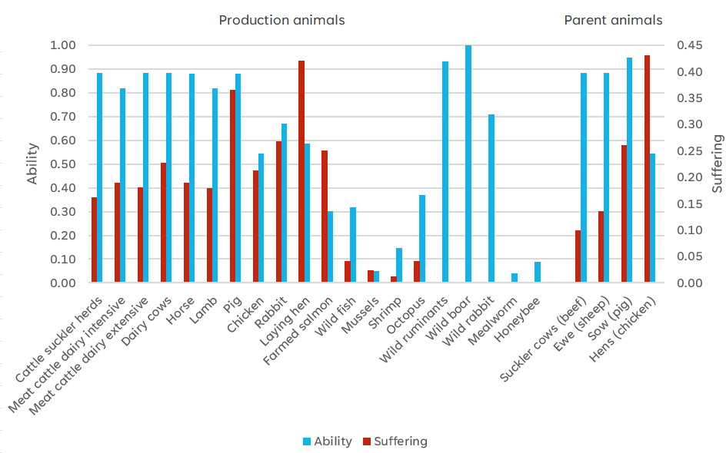
Fig. 1. Ability to perceive negative effects of being used by humans for different animal species (relative value from 0 to 1 based on expert scoring, in blue) and suffering per animal (red) for production animals and parent animals. Suffering is normalised against a ‘dystopia’ scenario with the score of 7. Suffering reflects German production of farm animals, Norwegian farmed salmon production, and non-country specific insect production and shooting and catching of wild animals.

As for suffering, hens had the highest scores due to high disease frequency; an average of more than 40% of hens suffer from keel bone fractures at the end of the production period (Rufener and Makagon, 2020). Pigs also had high suffering scores due to high piglet mortality and lack of space (Fig. 1 and Table 3). Production of farm animals in Germany is used as an example here, but suffering varies between countries. For ruminants, grazing season length and proportion of animals on pasture have a large influence on lack of space. Results for all countries are presented in SM1. Wild animals on land had considerably lower suffering scores, stemming only from shooting (assuming the slaughter duration was one minute) which was the only human-induced suffering for these animals.

Table 3. Mortality, disease frequency, slaughter duration and lack of space for different species and production systems. Data reflects German production of farm animals, Norwegian farmed salmon production, and non-country specific insect production and shooting and catching of wild animals.
 | Mortality ³ | Disease frequency ³ | Slaughter duration ⁴ | Lack of space ⁵
Production animals
Cattle in suckler herds | 0.04 | 0.05 | 0.25 | 0.27
Calves from dairy, intensive¹ | 0.07 | 0.10 | 0.25 | 0.17
Young cattle from dairy, extensive² | 0.08 | 0.05 | 0.25 | 0.27
Dairy cows | 0.06 | 0.16 | 0.25 | 0.21
Horse | 0.03 | 0.15 | 0.25 | 0.10
Sheep | 0.08 | 0.06 | 0.25 | 0.20
Pig | 0.23 | 0.15 | 0.25 | 0.63
Chicken | 0.04 | 0.10 | 0.17 | 0.60
Rabbit | 0.15 | 0.11 | 0.25 | 0.34
Laying hen | 0.04 | 0.46 | 0.25 | 0.45
Farmed salmon | 0.16 | 0.15 | 0.25 | 0.03
Wild fish | 0 | 0 | 0.15 | 0
Blue mussels | 0 | 0 | 0.08 | 0
Shrimp | 0 | 0 | 0.04 | 0
Octopus | 0 | 0 | 0.15 | 0
Wild ruminants | 0 | 0 | 0.0007 | 0
Wild boar | 0 | 0 | 0.0007 | 0
Wild rabbit | 0 | 0 | 0.0007 | 0
Mealworm | 0 | 0 | 0.0007 | 0
Honeybee | 0 | 0 | 0.0003 | 0
Parent animals
Cattle in suckler herds, cow | 0.03 | 0.04 | 0.25 | 0.08
Sheep, ewe | 0.06 | 0.05 | 0.25 | 0.13
Pig, sow | 0.03 | 0.15 | 0.25 | 0.42
Chicken, hen | 0.06 | 0.46 | 0.17 | 0.39
¹ Calves reared indoors; slaughter age 10 months.
² Slaughter age 2 years; on pasture 3 months.
³ Share of animals
⁴ Share of 24h
⁵ Share of space occupied by animal

4.2 Animal welfare indices
Regardless of type of index used, meat from cattle and wild animals, mealworms and honey show low index values (i.e. favourable) per kg of animal product (Fig. 2). For mealworms and honey this is partly an effect of our adjustment of number affected (section 3.1.1). Without this adjustment the PAALA value for mealworms and honey would have been 27 (instead of 0.27) and 37 (instead of 0.37). Meat from cattle shows low values due to the large body mass in comparison to other livestock species, resulting in a low number affected as one animal gives many kg of meat. Meat from wild animals killed by shooting show low values per kg due to their low human induced suffering (Table 3). Wild animals from the sea show higher values due to a longer slaughter duration. The values for shrimps and blue mussels are influenced by the adjustment of number affected. Without this adjustment, the PAALA value for shrimps and blue mussels would have been 97 (instead of 9.7) and 36 (instead of 3.6).
For PAALA, rabbits and chicken have the highest values (i.e. unfavourable) due to high number affected as almost one animal is needed to produce one kg of meat (approximately 0.8 animals for chicken and 1.0 for rabbit; see SM1) and relatively high suffering scores due to relatively high disease frequency and lack of space (Fig. 2). For chicken production, number affected is similar across countries as the production system and genetic type are homogenous, while rabbit production can be performed using rabbit breeds of various sizes (Cesari et al., 2018) which influences the number affected and hence assessment results.
When accounting for the time an animal lives before slaughter as in ALYS and PAALYS, farmed salmon scores worst of all species, due to relatively long life duration (3 years compared to 5 weeks for chicken; see SM1). For the same reason, eggs have higher values relative other products when measured with ALYS or PAALYS compared to PAALA (Fig. 2).
Adjusting for animals’ ability to perceive negative effects of being used by humans in PAALYS compared to ALYS did not change the ranking between food products but made the difference between food from farmed salmon and from chicken, rabbit and laying hen less pronounced as salmon was judged to have a lower such ability (Fig. 1).
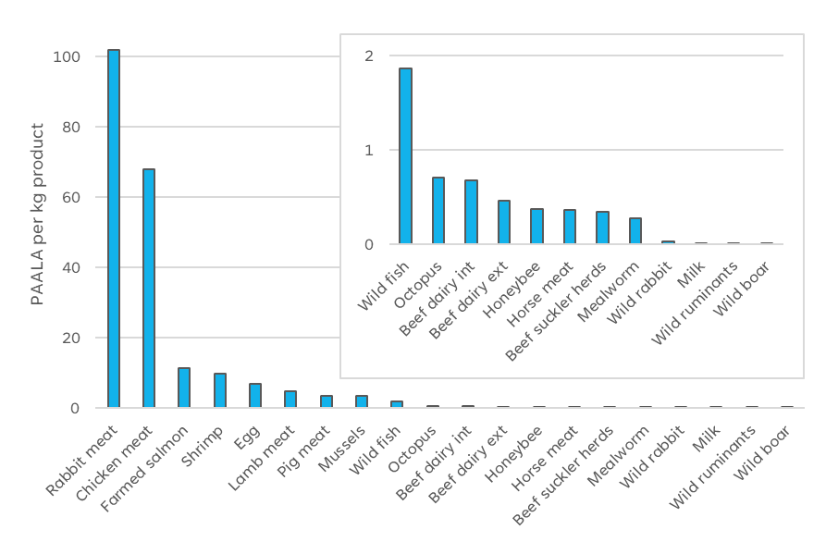
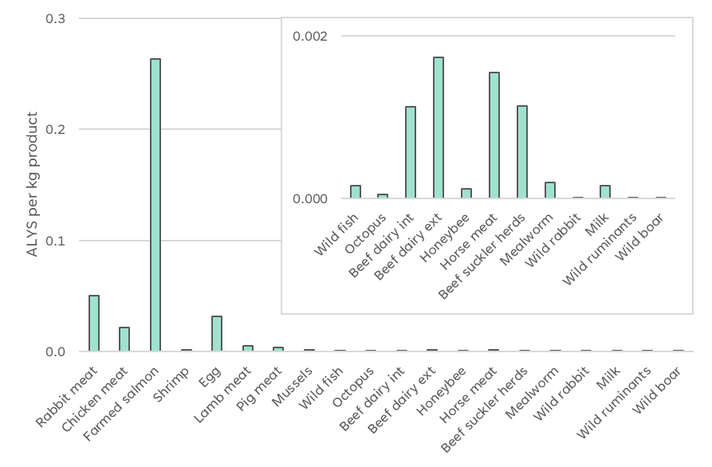
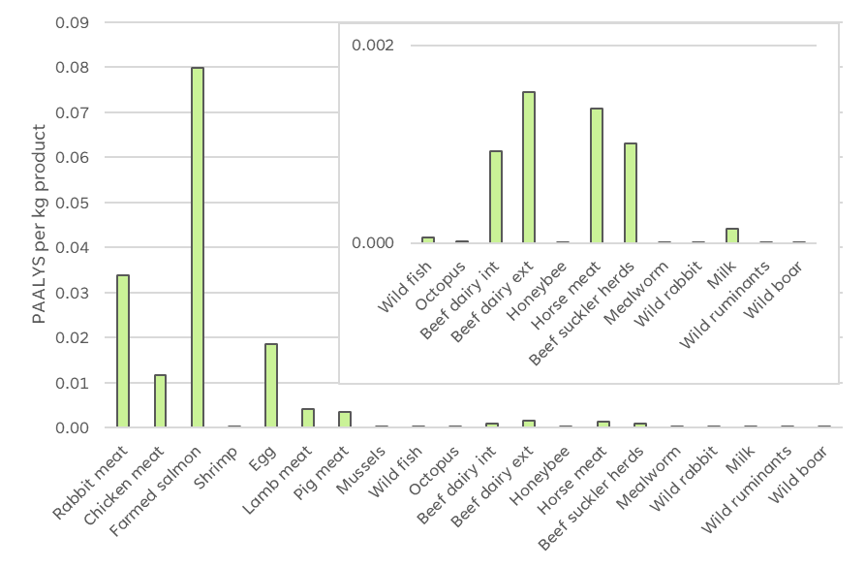
Fig. 2. Three different animal welfare indices for animal products: Perception Adjusted Animal Lives Affected (PAALA), Animal Life Years Suffered (ALYS) and Perception Adjusted ALYS (PAALYS). The indices reflect German production of farm animals, Norwegian farmed salmon production, and non-country specific insect production and shooting and catching of wild animals. The inset image provides a magnified view of the lower range of the main bar chart.

4.3 Country difference for animal welfare assessment
Variations in PAALA and PAALYS between animal products produced in different countries (Fig. 3) stem mainly from differences in suffering, reflecting varying mortality, disease frequency, lack of space and slaughter duration. Variation in index values for eggs depend on varying space allowances between countries with Hungary, Poland and Spain offering the least space for laying hens due to a large share of hens kept in cages, while France, Germany and Sweden keep more than 90% of the laying hens in free-range systems (SchukPaim et al., 2021). For PAALYS, differences in suffering between countries lead to more pronounced country differences in the overall value as suffering is multiplied by the life duration which is relatively long for laying hens.

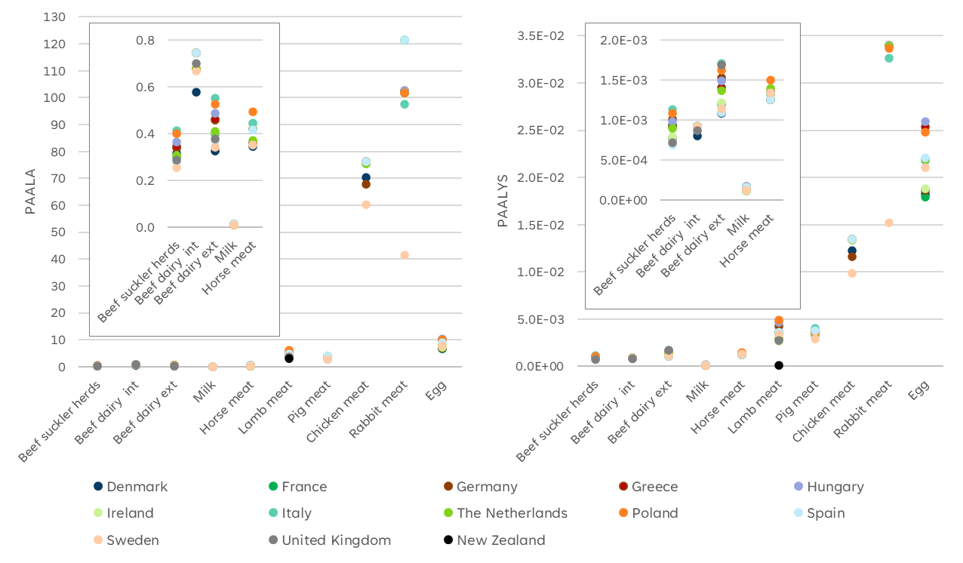Fig. 3. Perception Adjusted Animal Lives Affected (PAALA) and Perception Adjusted Animal Life Years Suffered (PAALYS) for livestock products produced in different countries. The index value of a country can be hidden behind another country. The inset image provides a magnified view of the lower range of the main bar chart.

The relatively low value for Swedish chicken meat in comparison with other countries stems from larger space allowances for chicken in Sweden compared to other countries and lower disease frequency (see SM1). The low value for Swedish rabbit meat is also explained by the Swedish animal welfare law with large space requirement but also by larger animals being used in Sweden (giving lower number affected). However, commercial rabbit production is very small in Sweden (and in Denmark and Ireland; no data for these countries included here). Lamb meat from New Zealand has the lowest value of all lamb meat as lambs are raised entirely on pasture which results in the best possible score for lack of space (Fig. 3). This is despite a higher mortality in New Zealand’s lamb production as compared to European lamb production (see SM1).
Patterns in between country variation are similar for PAALA and PAALYS (Table 4). Pig meat from Italy presents an exception. With PAALA, Italian and Swedish pig meat has the lowest value, i.e. most favourable (Italian due to lower number affected and Sweden due to lower suffering), while with PAALYS, which also considers the life duration before slaughter, Italian pig meat score the worst of all pig meat. This is because Italian pigs are raised to a higher age (nine instead of six months) and when animal welfare loss is measured with PAALYS living longer means that suffering is extended during a longer period and the index value is higher.

Table 4. Perception Adjusted Animal Lives Affected (PAALA) and Perception Adjusted Animal Life Years Suffered (PAALYS) for 1 kg of livestock products produced in different countries.
 | Beef fr suckler herds | Beef fr dairy, intens. | Beef fr dairy extens. | Milk | Horse meat | Lamb meat | Pig meat | Chicken meat | Rabbit meat | Egg
Perception Adjusted Animal Lifes Affected (PAALA)
Denmark | 0.32 | 0.58 | 0.33 | 0.010 | 0.35 | 4.12 | 3.68 | 70.34 |  | 6.71
France | 0.30 | 0.74 | 0.40 | 0.008 | 0.42 | 4.57 | 3.76 | 76.38 | 121.3 | 6.81
Germany | 0.34 | 0.68 | 0.46 | 0.010 | 0.36 | 4.91 | 3.57 | 67.86 | 101.9 | 6.90
Greece | 0.35 | 0.74 | 0.46 | 0.013 | 0.42 | 3.83 | 3.69 | 76.38 | 102.7 | 9.93
Hungary | 0.36 | 0.74 | 0.49 | 0.013 | 0.44 | 5.95 | 3.58 | 76.36 | 102.7 | 10.4
Ireland | 0.31 | 0.74 | 0.41 | 0.008 | 0.44 | 3.55 | 3.56 | 76.38 |  | 7.35
Italy | 0.41 | 0.74 | 0.55 | 0.011 | 0.44 | 3.83 | 2.85 | 76.38 | 97.6 | 8.51
NL | 0.31 | 0.68 | 0.41 | 0.009 | 0.37 | 3.33 | 3.44 | 75.32 | 101.9 | 8.14
Poland | 0.40 | 0.74 | 0.53 | 0.011 | 0.49 | 6.20 | 3.69 | 76.36 | 101.9 | 10.0
Spain | 0.28 | 0.74 | 0.37 | 0.012 | 0.42 | 4.62 | 3.87 | 76.36 | 121.3 | 8.85
Sweden | 0.26 | 0.67 | 0.34 | 0.008 | 0.35 | 3.83 | 2.82 | 60.40 | 41.6 | 7.71
UK | 0.29 | 0.70 | 0.38 |  |  | 3.59
NZ |  |  |  |  |  | 3.06
Perception Adjusted Animal Life Years Spent (PAALYS) x 0.01
Denmark | 0.093 | 0.080 | 0.11 | 0.012 | 0.13 | 0.36 | 0.37 | 1.22 |  | 1.82
France | 0.077 | 0.092 | 0.12 | 0.011 | 0.13 | 0.36 | 0.36 | 1.34 | 4.01 | 1.80
Germany | 0.100 | 0.092 | 0.15 | 0.014 | 0.14 | 0.43 | 0.36 | 1.16 | 3.39 | 1.86
Greece | 0.091 | 0.092 | 0.14 | 0.017 | 0.13 | 0.29 | 0.35 | 1.34 | 3.40 | 2.54
Hungary | 0.098 | 0.092 | 0.15 | 0.017 | 0.13 | 0.47 | 0.33 | 1.34 | 3.40 | 2.60
Ireland | 0.079 | 0.092 | 0.12 | 0.011 | 0.13 | 0.27 | 0.33 | 1.34 |  | 1.88
Italy | 0.110 | 0.092 | 0.17 | 0.015 | 0.13 | 0.29 | 0.40 | 1.34 | 3.26 | 2.17
NL | 0.089 | 0.092 | 0.14 | 0.013 | 0.14 | 0.29 | 0.33 | 1.34 | 3.39 | 2.19
Poland | 0.110 | 0.092 | 0.16 | 0.014 | 0.15 | 0.49 | 0.35 | 1.34 | 3.36 | 2.48
Spain | 0.069 | 0.092 | 0.11 | 0.016 | 0.12 | 0.36 | 0.38 | 1.34 | 4.01 | 2.21
Sweden | 0.073 | 0.091 | 0.11 | 0.012 | 0.13 | 0.34 | 0.29 | 0.99 | 1.52 | 2.10
UK | 0.072 | 0.087 | 0.17 |  |  | 0.27
NZ |  |  |  |  |  | 0.009

4.4 Antibiotic use indicator
Results for the antibiotic use indicator for animal products from a subset of countries are shown in Fig. 4 (results for all included countries in SM2). Egg and milk have the lowest values due to large production of eggs and milk per animal. Across species, the index value is highest for rabbit meat (SM2) followed by pig meat. Meat from cattle has a lower antibiotic use indicator than lamb meat since a large part of the antibiotics used for cattle is allocated to milk. The ranking between countries is the same for all food products, as a consequence of our method.

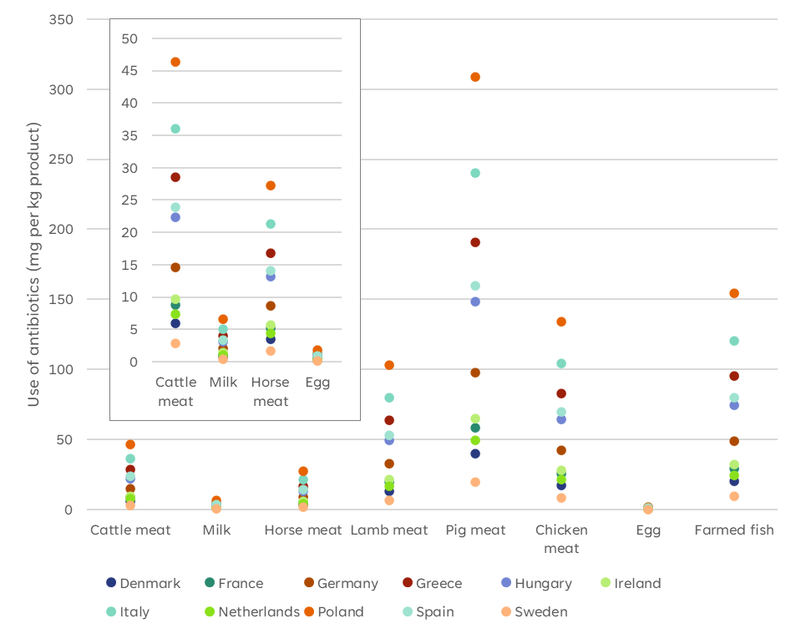Fig. 4. Antibiotic use indicator per kg of product from different countries. The index value of a country can be hidden behind another country. The inset image provides a magnified view of the lower range of the main bar chart.

5. Discussion
In academic discussions concerning sustainability, it is recognized that science alone cannot determine whether animal welfare or threats to human health should be prioritized, as these decisions are influenced by personal and societal values. However, scientific evidence can provide a foundation for making informed decisions in these areas. In this article, we have developed metrics for assessing animal welfare loss and antibiotic use, which can be used alongside environmental metrics to evaluate impacts from food consumption in diet assessments (e.g. Eustachio Colombo, 2023) and food system modelling studies (van Zanten et al., 2022). The aim of these metrics is to bring in the aspects of animal welfare and antibiotic use to provide more comprehensive decision support to assist various stakeholders, such as politicians, policymakers in food and agriculture industry, producers, and consumers.
It is important to note that our metrics are not intended for monitoring or improving livestock production practices. For instance, only a small number of parental animals are needed per kg food product, therefore their contribution to the overall animal welfare index is minimal. Consequently, even a very low animal welfare value for parental animals would have little impact on the overall animal welfare index value. Therefore, assessing and acting on animal welfare indices on a diet level is far from enough; efforts to improve animal welfare of all parent and production animals need to continue regardless how they score in our indices, including reducing mortality, disease frequency and slaughter duration and increase space allocation. Never the less, diet assessments performed with our metrics could motivate the industry to improve livestock production systems. Likewise, diet assessments could increase consumers’ awareness of the consequences of their diets for animal welfare and threats to human health.

5.1 Design of the animal welfare indices
Suffering in our indices includes indicators crucial for animal welfare: mortality, disease frequency, lack of space and slaughter duration. The corresponding ‘life quality’ used by Scherer et al. (2018) included only one indicator. We believe suffering or quality of life is better described when including more than one aspect, and chose four indicators. A potential fifth indicator could have reflected mutilation routines such as castration, tail docking and beak trimming. Feasibility, however, decreases with number of indicators and feasibility is a quality criterion for assessment tools, as stated by Richter et al. (2024). We based the weighting of the four indicators on a previous pig study (Zira et al., 2020). This is a limitation, since the relative importance of the four different indicators may differ between animal species.
The consumption of 1 kg honey involves the life of 12 000 honeybees, while one pig life is enough for consuming more than 50 kg meat. Globally, number of animals affected is increasing due to increasing meat consumption and an ongoing shift towards chicken meat, making number of animals affected increase much faster than total meat consumption (Van der Laan et al., 2024). We have taken animal lives into account in our animal welfare assessment and so has Scherer et al. (2019), Paris et al. (2022) and Allenden et al. (2022). To what degree the number of animal lives is relevant varies between individuals and ethical perspectives. With the excel sheet in the supplementary material (SM1), readers can see the consequence of taking away our adjustment of number affected for ‘very small’ animals in the PAALA index, or the consequence of an adjustment of number affected also for ‘rather small’ animals like chickens and rabbits.
While data on various forms of animal suffering in different production systems can be improved with additional studies and industry reports, it remains difficult to compare animals with differing cognitive capacities. In previous assessments (Scherer et al., 2019; Paris et al., 2022; Allenden et al., 2022), physiological characteristics, such as number of cortical neurons and brain weight, were used in the assessments. However, comparable physiological data for all species used in human food production are unlikely to be available soon, and the validation of such metrics in welfare assessments remains incomplete. Thus, we chose to gather data on ability to perceive negative effects of being used by humans using a questionnaire to researchers in animal science and veterinary medicine (section 3.1.2). The scoring was subjective, based on the respondents’ knowledge, experience and intuition; it reflects humans’ perception of animals’ ability to perceive negative effects. This is a limitation, but we believe it is a better choice than using inadequate physiological characteristics.
Species rankings concerning moral value were similar in Scherer et al. (2018) and Paris et al. (2022) with cattle ranked as having the highest value followed by pigs, chickens, salmon, crickets (Scherer et al. 2018) / honeybees (Paris et al. 2022) and shrimp. Respondents to our questionnaire on animals’ ability ranked pigs first, followed by cattle, chickens, salmon, crickets, and honeybees (Fig. 1). The relative ability to perceive negative effects or moral value assigned to smaller species, such as shrimp and insects, varied substantially across studies. For instance, Scherer et al. (2018) assigned crickets a value 0.00004 times that of pigs, whereas in our questionnaire, the value for honeybees was 0.16 times that of pigs. The scale (summing up to 110 000 points) could potentially have influenced the results, but the respondents were told that they could give less than 1 point to one or several species. One respondent gave 0 points to honeybees (SM4).
It is essential to consider that our adjustment of number involved (section 3.1.1) lacks a scientific basis, but was deemed necessary to achieve a reasonable assessment of the animal welfare loss across species. The deviation between respondents was larger for the ‘small’ animals, i.e. meal worm, honey bee, blue mussel and shrimp (see SM4), for which the numbers were adjusted, as compared to mammals and birds. The adjustment of numbers could thus partly be seen as an adjustment based on uncertainty. Richter et al. (2024) state that different weights could “reflect empirical uncertainties about whether animal species fulfil relevant criteria for moral consideration”.
We agree with Richter et al. (2024) that inter-species weighting should be regarded as provisional and adjusted to new empirical and ethical findings. The relative values for animals’ ability to perceive negative effects that we used in PAALA and PAALYS can easily be replaced by relative values based on physical characteristics if such data become available for all species included in diets. Meanwhile, we encourage readers to use the questionnaire (SM4) to perform their own assessments of animals’ ability to perceive negative effects of being handled by humans. Feedback from some of the respondents indicated that familiarity with a species tends to result in assigning them a higher value. It would be interesting to use the questionnaire to a larger group of experts and study associations between their research area and their distribution of points. Instead of relying on experts in animal science or veterinary medicine, stakeholders such as consumers or policymakers could be asked to complete questionnaires regarding animals' ability to perceive negative effects. ALYS avoids addressing the contentious issue of how to compare species with different cognitive capacities, which leads to larger welfare losses for species like salmon compared to mammals (Fig. 2).
The PAALA index does not account for the length of life and the slaughter process is included in the suffering (section 3.1.3). Suffering during slaughter is given lower weight than that given to mortality, disease frequency and lack of space, reflecting the short slaughter duration relative to the animal’s lifetime. Still, the impact of slaughter duration is more influential in PAALA than in the ALYS and PAALYS indices. Handling time in animal welfare assessments is complex, as Zira et al. (2020) noted in an evaluation of pork production systems. For wild species not subject to human-controlled living conditions, counting each day as a day of suffering, as in ALYS and PAALYS, is misleading. Seeing a shorter lifespan as favourable for welfare also means that a production system where e.g. pigs are slaughtered at 5.5 months scores better than a system where pigs are slaughtered at 6.0 months, given the same slaughter weight in both systems. ALYS and PAALYS may therefore disadvantage systems where animals are reared in less intensive, more welfare-friendly environments but have longer lifespans.
When comparing PAALA and PAALYS, the ‘worst’ and the ‘best’ country within food product are often the same with both indices (with Italian pig meat being an exception, as described in 4.3). Comparing beef from dairy calves reared in intensive versus extensive production systems reveals a difference between the two indices. The intensive system has higher PAALA values (more unfavourable) than the extensive system in all countries, partly due to higher number affected (lower slaughter weight) and partly to higher disease frequency. The extensive system has higher PAALYS values than the intensive system, due to a longer life span (two years, as compared to ten months for the intensive system). Based on the results presented in section 4.1 and discussed in this section, we think PAALA is a more useful indicator of animal welfare loss in diet assessments than PAALYS and ALYS.

5.2 Design of the antibiotic use indicator
To our knowledge, no indicator specifically measuring the risk of antibiotic resistance has been included in dietary assessments, despite the World Health Organization (WHO) identifying antibiotic resistance as a critical threat to human health. Although Life Cycle Assessment (LCA) studies can assess the direct toxicity of antibiotics, they do not account for the broader public health risks associated with resistance (Nyberg et al., 2021). In addition to accounting for the sales of antibiotics for farm animals as reported by ESVAC, i.e. as the total use in a country divided on livestock units, we also account for the distribution of different species within countries and differences between species in the typical use of antibiotics in today’s production systems. However, the later suffers from limitation in data availability. As more detailed species-specific data become available it will be possible to refine the antibiotic use indicator and improve its accuracy. Such reporting is ongoing for cattle, pigs, chickens, laying hens, and turkeys (starting 2024), and planned for 2027 for sheep, goats, fish, rabbits and horses in the European union (EU, 2021). The coming species specific data will also show the correctness of our assumption that the proportion of antibiotics used for different species (in mg per PCU) within country is the same in all countries. Simply using national total use of antibiotics as reported by ESVAC (2023), without adjusting for species distribution in different countries and typical use across species (as we did in the antibiotic use indicator) resulted in almost the same results (SM2, Simple indicator). For Ireland, which produces low amounts of pig meat, the assessment with the antibiotic use indicator is, however, less favourable than an assessment based only on the total national use of antibiotics.

5.3 Data limitations
The quality of production systems with respect to animal welfare (which we termed suffering as it solely includes negative aspects of animal welfare loss) encompasses four aspects; mortality, disease frequency, lack of space and slaughter duration. Scherer et al. (2018) included only one welfare aspect per species. However, the limitations posed by incomplete data and variability in data quality remain substantial challenges. A logical progression for this research would be to assess specific production systems rather than relying on national averages, as we have done. Sandøe and co-workers have developed a tool for benchmarking animal welfare across countries based on legislation, welfare labels, market-shares and welfare consequences expected by experts. Sweden had a much better benchmark for chicken production due to higher legal standards than the Netherlands, UK, Germany and Denmark (Sandøe et al., 2022), which is in accordance with suffering in our study. The benchmark for consumption was, however at the same level for the Netherlands and Sweden, because a relatively large part of the Dutch consumption is welfare labelled chicken, whereas the exported chicken is produced according to the minimum legal requirements (Sandøe et al., 2022). When comparing pig production, Sweden and UK had the highest welfare, followed by Netherlands and Germany and Denmark (Sandøe et al., 2020). The rank order of Sweden, Netherlands, Germany and Denmark is the same for suffering in our study. Sweden had a lower benchmark score for consumption than for production, due to import (Sandøe et al., 2020). Our indices can be further developed by assessing different kinds of production systems not only for beef (where we assessed three systems) but also for other species. For instance, organic and conventional pig production systems can differ substantially within a country in terms of both social and environmental sustainability factors (Zira et al., 2021).
Hebinck et al. (2021) suggests share of certified organic products as an indicator of animal welfare. Åkerfeldt et al. (2020) reviewed 166 scientific studies and found no strong evidence for higher over-all animal welfare in organic compared with conventional production but concluded that the possibilities to perform species-specific behaviours is better in organic production systems. Data on outdoor access and available space per animal can be sourced from the rules governing certified production systems (e.g., EU organic production regulations), but obtaining data on mortality, disease frequency and slaughter duration for specific production systems is more challenging. The use of antibiotics is more strictly regulated in organic compared to conventional production systems, with extended withdrawal periods after treatment (EC, 2018), yet detailed data on antibiotic use for different production systems are unlikely to become available in the near future.
Our assessment of lack of space is primarily based on animal welfare legislation in the EU and specific countries, along with the amount of time animals spend on pasture. Since average data on space availability in practice for all species and countries are lacking, this may lead to an underestimation of welfare loss, especially given that not all farms comply fully with legal requirements. General indices of law compliance, such as the World Justice Project Rule of Law Index (WJP, 2023) offer a proxy for estimating compliance levels. According to WJP (2023), countries included in our study are ranked (from worst to best) as follows: Hungary (0.51), Greece (0.61), Poland (0.64), Italy (0.67), Spain (0.72), France (0.73), Ireland (0.81), Germany (0.83), and Sweden (0.85). Such law compliance values could be used to adjust animal welfare and antibiotic use indices.
In cases where comparable data across countries are absent, we have made necessary assumptions. One such assumption is that the average transport time for different species, as reported by the European Court of Auditors (ECA, 2023), is adequate for calculating slaughter duration. Another assumption pertains to countries that have advocated for an 8-hour maximum transport time for live animals within the EU, where we have presumed shorter transport durations compared to other European nations (see SM1, Slaughter). Such assumptions are open to debate, particularly regarding the point at which data should be considered ‘missing’ in sustainability assessments and how to address these gaps. An example of ‘missing’ data concerns suffering for honeybees. Honey bees are not slaughtered and we found no data on individual mortality or disease frequency and lack of space seems irrelevant. Suffering is multiplied with the other components of the animal welfare indices and thus a suffering-value of zero is not an option. We handled this pragmatically by giving honeybees an arbitrary short slaughter duration – would it have been better to exclude honey from the diet assessment? Where specific country-level data on production systems were unavailable, we used average data from other countries, or data from only one country. To address the issue of missing comparable data in diet assessments across countries, we have documented references, assumptions and simplifications in the supplementary material (SM1-5). As concluded by Richter et al (2024), “indicators for assessing animal welfare at scale need to be developed and an extensive and transparent database for these indicators built”.
The timeliness of references is critical when utilizing data from various sources related to animal production. This is particularly evident in the context of antibiotic use, where the general trend is toward reduced use across countries, although the pace of this reduction varies between countries (ESVAC, 2023). Ideally, all data would reflect the same time period to ensure a fair and accurate assessment. In the case of the animal welfare indices, some of the oldest references for disease frequency and mortality date back to the beginning of this millennium and changes in management routines can have substantial impacts on suffering. Consequently, the indices presented here should be updated regularly to reflect new data.
The animal welfare indices used in this study focus exclusively on welfare loss, or negative welfare aspects, which may give the impression that animal welfare is solely concerned with problems. However, research into the measurement of positive welfare aspects, with records on play behaviour and facial expressions, is ongoing (Matiello et al., 2019). At present, the data necessary to incorporate positive welfare aspects into diet assessments are insufficient. Should such data become available in the future, it may be possible to integrate both negative and positive aspects into a single index. However, this approach risks allowing positive and negative aspects to cancel each other out; for example, high mortality could be obscured by frequent play events. An alternative solution might be to present two separate indices: one focusing on negative welfare aspects and the other on positive welfare aspects.

5.4 Interpretation of results
Although our metrics for animal welfare and antibiotic use share a common functional unit, their scales differ, making direct comparison impossible. This is critical to remember when interpreting visual representations, such as the figures presented in the supplementary material SM3-a. In this case, we adjusted the scales of the y-axes to fit within the same figure, which could misleadingly suggest that the impacts of a diet on animal welfare and antibiotic use are of the same magnitude just because the staples are of the same size.
An alternative to relative comparisons is to relate the results to absolute targets or boundaries, though establishing such benchmarks for food and diets is challenging. While some attempts have been made for environmental impacts (Karlsson Potter and Röös, 2021; Moberg et al., 2020), establishing similar targets for animal welfare and antibiotic use remains complex. For instance, the European Public Health Alliance recommends that use of antibiotics should remain below 30 mg per population correction unit (PCU), with a long-term target of 15 mg or less (Nunan, 2022). The Nordic countries are already below this threshold; thus, setting the goal at 15 mg in assessments would overlook the substantial efforts made by farmers, advisors, and veterinarians in these countries. This raises the broader issue of who should set such targets. Slätmo et al. (2016) argue that the use of indicator-based frameworks to assess sustainability represents "an expression of power by the developers of the framework."
There is a risk that assessments of food products based on national data may be interpreted as if all products (e.g., all chicken meat) from a given country have uniform impacts. This is misleading, as practices vary widely. For instance, international fast-food companies may impose high standards for housing, management, and slaughter processes, independent of the country in which animals are raised. National-level diet assessments often fail to account for such programs.
When interpreting projections of future diets (as in the supplementary material, SM3a), it is essential to consider the feasibility of producing sufficient food to meet dietary demands. For example, our animal welfare index values show substantially lower welfare loss for meat from wild animals killed by shooting compared to farm animals (Figure 2). Additionally, wild animals are not treated with antibiotics. Consequently, replacing farmed meat with wild game would be highly beneficial for animal welfare and antibiotic use (as well as climate impact). However, wild animal populations are insufficient to meet current meat consumption levels.
Vinnari and Vinnari (2022) assert that “non-human animals are largely invisible in discussions of sustainability and associated accounting efforts.” It is hoped that our work, alongside studies by Scherer et al. (2018; 2019), Paris et al. (2022), Allenden et al. (2022), Van der Laan et al. (2024) and Richter et al (2024), will help to bring greater visibility to the welfare of both wild and domesticated animals in these discussions. However, it is important to recognize that comparable and readily available data are scarce, that the indices developed here involve simplifications, and that the design of the welfare index affects outcomes, as does the way results are presented.

6. Conclusions
We have developed metrics for assessing animal welfare and antibiotic use to be used in sustainability assessment of diets and food systems. While scientific evidence can inform decisions, societal and personal values shape the prioritization of issues like animal welfare and threats to human health. Our metrics aim to quantify welfare loss and antibiotic use but do not replace the need for ongoing improvements in livestock production practices, such as reducing mortality and disease rates. Comparing species with different cognitive capacities presents challenges, but our method offers a starting point. More data is needed to refine these metrics, especially for species-specific antibiotic use and welfare outcomes across different production systems. The new PAALA index for assessing animal welfare loss developed here presents an alternative perspective in relation to similar previously developed animal welfare indices as it does not see lifetime as problematic per se but focus on number of animals affected, their ability to perceive negative effects of being used by humans and the quality of the production system. Despite the limitations in data availability and the complexity of balancing various aspects, our work underscores the need to account for animal welfare and risk of antibiotic resistance alongside environmental considerations in diet assessments. It also highlights the necessity of updating these metrics regularly to reflect new data, while cautioning against over-reliance on simplified assessment methods that may obscure important nuances in welfare outcomes.

Declaration of interests
The authors have no competing interests to declare.

Acknowledgements
Funding for this study come from Mistra Food Futures (DIA 2018/24 #8), a research program funded by Mistra (The Swedish Foundation for Strategic Environmental Research) and Plan’eat funded by the European Union’s Horizon Europe Research and Innovation programme under Grant Agreement n° 101061023. All funding is gratefully acknowledged. Our thanks also to C. Berg, G. Bernes, S. Eriksson, A. Gräns, S. Gunnarsson, L. Holm, M. Jacobson, L. Keeling, F. Lundmark Hedman, K. Nilsson, E. Sandberg, E. Strandberg, C.-G. Thulin, A. Wallenbeck and T. Wallgren at SLU who answered the animal welfare questionnaire and participated in the workshop, and to U. Magnusson at SLU who gave valuable advices about the antibiotic use indicator.

CRediT authorship contribution statement
Lotta Rydhmer: Conceptualization, Methodology, Investigation, Formal analysis, Writing – original draft. Elin Röös: Conceptualization, Methodology, Investigation, Formal analysis, Writing – review and editing, Funding acquisition.

AI statement
During the preparation of this work the authors used ChatGPT v3.5 for language editing. After using this tool, the authors reviewed and edited the content as needed, and the authors take full responsibility for the content of the publication.

Appendix A. Supplementary data
Supplementary data to this article can be found online at …

References
AGES. 2023. Antibiotic sales volumes in veterinary medicine. Österreichische Agentur für Gesundheit und Ernährungssicherheit GmbH. https://www.ages.at/en/animal/veterinary-medicines-hormones/antibiotic-sales-volumes-in-veterinary-medicine
Åkerfeldt, M.P., Gunnarsson, S., Bernes, G., Blanco-Penedo, I. 2020. Health and welfare in organic livestock production systems—a systematic mapping of current knowledge. Organic Agriculture 11, 105–132. https://doi.org/10.1007/s13165-020-00334-y
Allenden, N., Hine, D.W., Craig, B.M., Cowie, A.L., McGreevy, P.D., Lykins, A.D. 2022.
What should we eat? Realistic solutions for reducing our food footprint. Sustainable
Production and Consumption 32, 541–549. https://doi.org/10.1016/j.
spc.2022.05.008.
Alliance to save our antibiotics. 2020. New European Union rules on farm antibiotic use. https://www.saveourantibiotics.org/media/1842/2022-changes-to-european-law-farm-antibiotics.pdf
Aslam, B., Asghar, R., Muzammil, S., Shafique, M., Siddique, A.B., Khurshid, M., Ijaz, M., Rasool, M.H., Chaudhry, T.H., Aamir, A., Baloch, Z. 2024. AMR and sustainable development goals: at a crossroads. Global Health 20, 73. https://doi.org/10.1186/s12992-024-01046-8
Bartlett, H., Zanella, M., Kaori, B. et al. 2024. Trade-offs in the externalities of pig production are not inevitable. Nature Food 5, 312–322. https://doi.org/10.1038/s43016-024-00921-2
Birch, J., Burn, C., Schnell, A., Browning, H., Crump, A. 2021. Review of the evidence of sentience in cephalopod molluscs and decapod crustaceans. The London School of Economics and Political Science. London, LSE Enterprise Ltd.
Blokhuis, H., Miele, M., Veissier, I., Jones, B., editors. 2013. Improving farm animal welfare: Science and society working together: the Welfare Quality Approach. Wageningen Academic Publishers, Wageningen, the Netherlands.
Breen, M., Anders, N., Humborstad, OB., Nilsson, J., Tenningen, M., Vold, A. 2020. Catch Welfare in Commercial Fisheries. In: Kristiansen, T., Fernö, A., Pavlidis, M., van de Vis, H. (eds) The Welfare of Fish. Animal Welfare, vol 20. Springer, Cham. https://doi.org/10.1007/978-3-030-41675-1_17
Broom, D.M. 2011. A History of Animal Welfare Science. Acta Biotheor 59, 121–137. https://doi.org/10.1007/s10441-011-9123-3
Cajas de Gliniewicz, L. 2016. From trout to mollusks: Life cycle assessment, socio-economic attributes and ecosystem services surrounding sustainable aquaculture. PhD thesis. University of Idaho. US.
Cesari, V., Zucali, M., Bava, L., Gislon, G., Tamburini, A., Toschi, I. 2018. Environmental impact of rabbit meat: The effect of production efficiency. Meat Science 145, 447-454. https://doi.org/10.1016/j.meatsci.2018.07.011
Croppi, S., Yu, L., Robinette, C.S., Hassler, E.E., Newmark, A.J., Scott, A., Cazier, J., Song, J., Formato, G. 2021. Impact of legislation on antibiotic use and awereness of beekeepers. Journal of apicultural science 65, 265-274. DOI: 10.2478/JAS-2021-0022
DANMAP. 2021. Use of antimicrobial agents and occurrence of antimicrobial resistance in bacteria from food animals, food and humans in Denmark. ISSN 1600-2032. https://www.danmap.org/
EC. 2005. Ban on antibiotics as growth promoters in animal feed enters into effect. Press release IP/05/1687. European Commission, Brussels. https://ec.europa.eu/commission/presscorner/detail/en/IP_05_1687
EC. 2018. Regulation (EU) 2018/848 of the European Parliament and of the Council of 30 May 2018 on organic production and labelling of organic products. http://data.europa.eu/eli/reg/2018/848/oj
EC. 2020. Farm to Fork Strategy – for a fair, healthy and environmentally friendly food system. European Commission, Brussels. https://ec.europa.eu/food/farm2fork_en
ECA. 2023. Transport of live animals in the EU: challenges and opportunities. European Court of Auditors. https://www.eca.europa.eu/Lists/ECADocuments/RV-2023-03/RV-2023-03_EN.pdf
EEA, 2024. Veterinary antimicrobials in Europe’s environment: a One Health perspective. European Environment Agency Briefing no. 02/2024 doi:10.2800/041355
Erens, J., Es Van, S., Haverkort, F., Kapsomenou, E., Luijben, A. 2012. A bug’s life: large scale insect rearing in relation to animal welfare. Wageningen University and Research. Wageningen.
ESVAC. 2023. European Surveillance of Veterinary Antimicrobial Consumption (ESVAC): 2009 – 2023. European Medicines Agency, Amsterdam. https://www.ema.europa.eu/en/veterinary-regulatory-overview/antimicrobial-resistance-veterinary-medicine/european-surveillance-veterinary-antimicrobial-consumption-esvac-2009-2023
EU. 2019a. Regulation (EU) 2019/4 of the European Parliament and of the Council of 11 December 2018 on the manufacture, placing on the market and use of medicated feed. Official Journal of the European Union 2019. https://eur-lex.europa.eu/legal-content/EN/TXT/PDF/?uri=CELEX:32019R0004&from=EN
EU. 2019b. Regulation (EU) 2019/6 of the European Parliament and of the Council of 11 December 2018 on veterinary medicinal products. Official Journal of the European Union 2019. https://eur-lex.europa.eu/legal-content/EN/TXT/PDF/?uri=CELEX:32019R0006&from=EN
EU. 2021. Commission Delegated Regulation (EU) 2021/578 of 29 January 2021 supplementing Regulation (EU) 2019/6 of the European Parliament and of the Council with regard to requirements for the collection of data on the volume of sales and on the use of antimicrobial medicinal products in animals. European Union. https://eur-lex.europa.eu/eli/reg_del/2021/578/oj
EU. 2023. Attitudes of Europeans towards animal welfare. Eurobarometer. 2996 / SP533. https://europa.eu/eurobarometer/surveys/detail/2996
EU Council. 1998. Council Directive 98/58/EC of 20 July 1998 concerning the protection of animals kept for farming purposes, 8.8.1998. Council of the European Union. http://data.europa.eu/eli/dir/1998/58/oj
Eustachio Colombo, P., Elinder, L. S., Nykänen, E.-P. A., Patterson, E., Lindroos, A. K., Parlesak, A. 2023. Developing a novel optimisation approach for keeping heterogeneous diets healthy and within planetary boundaries for climate change. European Journal of Clinical Nutrition 78, 193–201. https://doi.org/10.1038/s41430- 023-01368-7
FAWC. 2009. Farm Animal Welfare in Great Britain: Past, Present and Future. Farm Animal Welfare Council. London, UK. https://assets.publishing.service.gov.uk/media/5a7d89fe40f0b64fe6c24508/Farm_Animal_Welfare_in_Great_Britain_-_Past__Present_and_Future.pdf
Ferroni L., Lovito C., Scoccia E., Dalmonte G., Sargenti M., Pezzotti G., Maresca C., Forte C., Magistrali C.F. 2020. Antibiotic Consumption on Dairy and Beef Cattle Farms of Central Italy Based on Paper Registers. Antibiotics 9, 273. doi: 10.3390/antibiotics9050273
Francione, G.L. 2010. Animal welfare and the moral value of nonhuman animals. Law, Culture and the Humanities, 6(1), 24-36. https://doi.org/10.1177/1743872109348989
Gibbons, M., Crump, A., Barrett, M., Sarlak, S., Birch, J., Chittka, L. 2022. Can insects feel pain? A review of the neural and behavioural evidence. Advances in Insect Physiology 63, 155–229. https://doi.org/10.1016/bs.aiip.2022.10.001
Halloran, A., Roos, N., Eilenberg, J., Cerutti, A., Bruun, S. 2026. Life cycle assessment of edible insects for food protein: a review. Agronomy for Sustainable Development 36, 57. doi: 10.1007/s13593-016-0392-8.
Hampton, J.O., Hyndman, T.H., Allen, B.L., Fischer, B. 2021 Animal Harms and Food Production: Informing Ethical Choices. Animals (Basel) 11(5):1225. https://doi.org/10.3390/ani11051225
Harrison, M.R., Palma, G., Buendia, T., Bueno-Tarodo, M., Quell, D., Hachem, F. 2022. A scoping review of indicators for sustainable healthy diets. Frontier in Sustainable Food Systems 5: 822263. https://doi.org/10.3389/fsufs.2021.822263
Hebinck, A., Zurek, M., Achterbosch, T., Forkman, B., Kuijsten, A., Kuiper, M., Nørrung, B., van’t Veer, P., Leip, A. 2021. A Sustainability Compass for policy navigation to sustainable food systems. Global Food Security 29, 100546. https://doi.org/10.1016/j.gfs.2021.100546
Herculano-Houzel, S. 2012. The remarkable, yet not extraordinary, human brain as a scaled-up primate brain and its associated cost. PNAS 109 (supplement_1) 10661-10668. https://doi.org/10.1073/pnas.1201895109
Humphry, R.W., Henry, M.K., Reeves, A. et al. 2021. Estimating antimicrobial usage based on sales to beef and dairy farms from UK veterinary practices. Vet Record 189(1), e28. https://doi.org/10.1002/vetr.28
Karlsson-Potter, H., Röös, E. 2021. Multi-criteria evaluation of plant-based foods –use of environmental footprint and LCA data for consumer guidance. Journal of Cleaner Production 280(1), 124721. https://doi.org/10.1016/j.jclepro.2020.124721
Keeling, L. 2005. Healthy and Happy: Animal Welfare as an Integral Part of Sustainable Agriculture. AMBIO: A Journal of the Human Environment 34(4), 316-319. https://doi.org/10.1579/0044-7447-34.4.316
Keeling, L., Tunón, H., Olmos Antillón, G., Berg, C., Jones, M. et al. 2019. Animal welfare and the United Nations sustainable development goals. Frontiers in Veterinary Science 6, 336. https://doi.org/10.3389/fvets.2019.00336
Lanzoni, L., Whatford, L., Atzori, A.S. et al. 2023. Review: The challenge to integrate animal welfare indicators into the Life Cycle Assessment. animal 17(5), 100794. https://doi.org/10.1016/j.animal.2023.100794
Lima, T., Dominques, S., Jorge Da Silva, G. 2020. Manure as a potential hotspot for antibiotic resistance dissemination by horizontal gene transfer events. Veterinary Sciences 7, 110. https://doi.org/10.3390/vetsci7030110
Maes, D.G.D., Dewulf, J., Piñeiro, C., Edwards, S., Kyriazakis, I. 2020. A critical reflection on intensive pork production with an emphasis on animal health and welfare, Journal of Animal Science 98, S15–S26. https://doi.org/10.1093/jas/skz362
Magnusson, U., Sternberg, S., Eklund, G., Rozstalnyy, A. 2019. Prudent and efficient use of antimicrobials in pigs and poultry. FAO Animal Production and Health Manual 23. FAO, Rome, Italy.
Mattiello, S., Battini, M., De Rosa, G., Napolitano, F., Dwyer, C. 2019. How can we assess positive welfare in ruminants? Animals 9, 758. https://doi.org/10.3390/ani9100758
Mestrovic, T. et al. 2022. The burden of bacterial antimicrobial resistance in the WHO European region in 2019: a cross-country systematic analysis. Lancet Public Health 7: e897–913. https://doi.org/10.1016/S2468-2667(22)00225-0
Miller, V., Reedy, J., Cudhea, F., Zhang, J., Shi, P., Erndt-Marino, J., Coates, J., Micha, R., Webb, P., Mozaffarian, D. 2022. Global, regional, and national consumption of animal-source foods between 1990 and 2018: findings from the Global Dietary Database. The Lancet Planetary Health 6, Issue 3, e243 - e256 https://doi.org/10.1016/S2542-5196(21)00352-1
Moberg, E., Karlsson Potter, H., Wood, A., Hansson, P.A., Röös, E. 2020. Benchmarking the Swedish Diet Relative to Global and National Environmental Targets—Identification of Indicator Limitations and Data Gaps. Sustainability 12, 1407. https://doi.org/10.3390/su12041407
Mood, A., Lara, E., Boyland, N.K., Brooke, P. 2023. Estimating global numbers of farmed fishes killed for food annually from 1990 to 2019. Animal Welfare 32, e12, 1–16. https://doi.org/10.1017/awf.2023.4
More, S.J., Marchewka, J., Hanlon, A., Balzani, A., Boyle, L. 2021. An evaluation of four private animal health and welfare standards and associated quality assurance programmes for dairy cow production. Food Policy 105, 102169. https://doi.org/10.1016/j.foodpol.2021.102169.
Murray, C.J.L. et al. 2022. Global burden of bacterial antimicrobial resistance in 2019: a systematic analysis. The Lancet 399: 629–55. https://doi.org/10.1016/S0140-6736(21)02724-0
Naranjo, A., Johnson, A., Rossow, H., Kebreab, E. 2020. Greenhouse gas, water, and land footprint per unit of production of the California dairy industry over 50 years. Journal of Dairy Science 103(4), 3760 – 3773. https://doi.org/10.3168/jds.2019-16576
NORM-VET, 2022. Usage of Antimicrobial Agents and Occurrence of Antimicrobial Resistance in Norway. NORM/NORM-VET 2021. Tromsø, Oslo. ISSN: 1890-9965. www.vetinst.no
Nunan, C. 2022. Ending routine farm antibiotic use in Europe. Achieving responsible farm antibiotic use through improving animal health and welfare in pig and poultry production. European Public Health Alliance (EPHA), Brussels. https://epha.org/wp-content/uploads/2022/02/report-ending-routine-farm-antibiotic-use-in-europe-final-2022.pdf
Nyberg, O., Rico, A., Guinée, J.B., Henriksson, P. 2021. Characterizing antibiotics in LCA—a review of current practices and proposed novel approaches for including resistance. International Journal of Life Cycle Assessment 26, 1816–1831. https://doi.org/10.1007/s11367-021-01908-y
Palmer, C., Sandøe, P. 2011. Animal ethics. In M. C. Appleby, J. A. Mench, I. A. S. Olsson, B. O. Hughes (Eds.), Animal welfare (2. ed., pp. 1-12). CABI Publishing
Paris, J., Falkenberg, T., Nöthlings, U., et al. 2022. Changing dietary patterns is necessary to improve the sustainability of Western diets from a One Health perspective. Science of The Total Environment 811:151437. https://doi.org/10.1016/j.scitotenv.2021.151437
Peng, X., Knouse, J.A., Hernon, K.M. 2015. Rabbit Models for Studying Human Infectious Diseases. Comparative Medicine 65, 499-507. https://pmc.ncbi.nlm.nih.gov/articles/PMC4681244/
Rauw, W. M., Kanis, E., Noordhuizen-Stassen, E.N., Grommers, F.J. 1998. Undesirable side effects of selection for high production efficiency in farm animals: A review. Livestock Production Science 56, 15–33.
Regan, T. 1985. The case for animal rights. University of California Press, Oakland.
Richter, S., Scherer, L., Hegwood, M., Bartlett, H., Bossert, L.N., Frehner, A., Schader, C. 2024. Conceptual framework for considering animal welfare in sustainability assessments of foods. Sustainable Production and Consumption 52, 179-209. https://doi.org/10.1016/j.spc.2024.10.004.
Röcklinsberg, H, Gamborg, C, Gjerris, M. 2014. A case for integrity: Gains from including more than animal welfare in animal ethics committee deliberations. Laboratory Animals 48, 61–71. https://doi .org/10.1177/0023677213514220.
Röös, E., Jacobsen, M., Karlsson, L., Wanecek, W., Spångberg, J., Mazac, R., Rydhmer, L. 2025. Introducing a comprehensive and configurable tool for calculating environmental and social footprints for use in dietary assessments. Journal of Cleaner Production 519, 146002. https://doi.org/10.1016/j.jclepro.2025.146002.
Rufener, C., Makagon, M. 2020. Keel bone fractures in laying hens: a systematic review of prevalence across age, housing systems, and strains, Journal of Animal Science 98, Issue Supplement_1, S36–S51, https://doi.org/10.1093/jas/skaa145
Sandøe, P., Hansen, H.O., Forkman, B., van Horne, P., Houe, H., de Jong, I.C., Kjær, J.B., Nielsen, S.S., Palmer, C., Rhode, H.L.H., Christensen, T. 2022. Market driven initiatives can improve broiler welfare - a comparison across five European countries based on the Benchmark method. Poultry Sci. 101(5):101806. doi: 10.1016/j.psj.2022.101806.
Sandøe, P., Hansen, H.O., Rhode, H.L.H., Houe, H., Palmer, C., Forkman, B., Christensen, T. 2020. Benchmarking Farm Animal Welfare-A Novel Tool for Cross-Country Comparison Applied to Pig Production and Pork Consumption. Animals (Basel) 10(6):955. doi: 10.3390/ani10060955
Scherer, L., Tomasik, B., Rueda, O. et al. 2018. Framework for integrating animal welfare into life cycle sustainability assessment. International Journal of Life Cycle Assessment 23, 1476–1490. https://doi.org/10.1007/s11367-017-1420-x
Scherer, L., Behrens, P., Tukker, A. 2019. Opportunity for a Dietary Win-Win-Win in Nutrition, Environment, and Animal Welfare. One Earth 1, 349-360. https://doi.org/10.1016/j.oneear.2019.10.020.
Schuck‑Paim, C., Negro‑Calduch, E., Alonso, W.J. 2021. Laying hen mortality in different indoor housing systems: a meta‑analysis of data from commercial farms in 16 countries. Scientific Reports 11, 3052. https://doi.org/10.1038/s41598-021-81868-3
Schwarzmueller, F., Kastner, T. 2022. Agricultural trade and its impacts on cropland use and the global loss of species habitat. Sustainability Science 17 (6), 2363–2377. https://doi.org/10.1007/s11625-022-01138-7
SDa. 2022. Usage of Antibiotics in Agricultural Livestock in the Netherlands in 2021. Trends and benchmarking of livestock farms and veterinarians. Netherlands Veterinary Medicines Institute (SDa) expert panel June 2022. https://www.autoriteitdiergeneesmiddelen.nl/en
Singer, P. 1975. Animal Liberation: A New Ethics for our Treatment of Animals. New York Review/Random House, New York.
Slätmo, E., Fischer, K., Röös, E. 2016. The Framing of Sustainability in Sustainability Assessment Frameworks for Agriculture. Sociologia Ruralis 57 (3), 378-395. https://doi.org/10.1111/soru.12156
Springman, M., Spajic, L., Clark, M., et al. 2020. The healthiness and sustainability of national and global food based dietary guidelines: modelling study. BMJ 370:m2322. https://doi.org/10.1136/bmj.m2322
Tallon, R.E., Whitt, B., Bladonm B.M. 2023. Antibiotic usage in 14 equine practices over a 10-year period (2012–2021). Equine Veterinary Journal 56, 544-551 doi.org/10.1111/evj.139888
TESCO. 2024. TESCO Antibiotics report April 2024. https://www.tescoplc.com/media/ajfhcqvp/antibiotic-report-2024.pdf
Thoma, G.J. Baker, B., Knap, P.W. 2024. A Life Cycle Assessment Study of the Impacts of Pig Breeding on the Environmental Sustainability of Pig Production. Animals 14(16), 2435; https://doi.org/10.3390/ani14162435
Tomás, M., Behrens, J.W., Nielsen, D.B. et al. 2024. Investigating the effects of pelagic trawling on the welfare of Atlantic herring (Clupea harengus). Scientific Reports 14, 17530. https://doi.org/10.1038/s41598-024-68629-8
Uddin, T.M., Chakraborty, A.J., Khusro, A., Zidan, B.R.M., Mitra, S., Bin Emran, T., Dhama, K., Ripon, M.K.H., Gajdács, M., Sahibzada, M.U.K., Hossain, M.J., Koirala, N. 2021. Antibiotic resistance in microbes: history, mechanisms, therapeutic strategies and future prospects. J. Infect. Public Health 14, 1750-1766 https://doi.org/10.1016/j.jiph.2021.10.020
UK-VARSS. 2022. Veterinary Antibiotic Resistance and Sales Surveillance Report (UK-VARSS 2021). New Haw, Addlestone: Veterinary Medicines Directorate. https://www.gov.uk/government/collections/veterinary-antimicrobial-resistance-and-sales-surveillance
UN. 2015. Transforming our world: the 2030 Agenda for Sustainable Development. Resolution Adopted by the General Assembly on 25 September 2015, A/RES/70/1.
UN Environment Assembly. 2022. Animal welfare–environment–sustainable development nexus. United Nations Environment Assembly of the United Nations Environment Programme. Fifth session. Resolution adopted 2 March 2022.
UNEP. 2023. Bracing for Superbugs: Strengthening environmental action in the One Health response to antimicrobial resistance. United Nations Environment Programme. Geneva. https://www.unep.org/resources/superbugs/environmental-action
van der Laan, S., Breeman, G., Scherer, L. 2024. Animal Lives Affected by Meat Consumption Trends in the G20 Countries. Animals 14, 1662. https://doi.org/10.3390/ani14111662
van Zanten, H.H.E., Muller, A., Frehner, A. 2022. 5 - Land use modeling: from farm to food systems. Editor(s): Christian Peters, Dawn Thilmany. Food Systems Modelling, Academic Press 89-105. https://doi.org/10.1016/B978-0-12-822112-9.00011-4
WellBeing International. 2022. Nexus between Animal Welfare, the Environment and Sustainable Development: Resource Document. (Ed. A.N. Rowan). First Edition. WellBeing International, Potomac, Maryland, USA. https://www.wellbeingintlstudiesrepository.org/es/nexus
WHO. 2020. The fight against Antimicrobial Resistance is closely linked to the Sustainable Development Goals. WHO/EURO:2020-1634-41385-56394. https://iris.who.int/bitstream/handle/10665/337519/WHO-EURO-2020-1634-41385-56394-eng.pdf. Downloaded October 2024.
Vinnari, E., Vinnari, M. 2022. Making the invisibles visible: Including animals in sustainability (and) accounting. Critical Perspectives on Accounting 82:102324. https://doi.org/10.1016/j.cpa.2021.102324
WJP. 2023. World Justice Project. https://worldjusticeproject.org/rule-of-law-index/global
WOAH. 2024. Terrestrial Animal Health Code. Terrestrial Code Online Access – WOAH - The World Organisation for Animal Health. https://www.woah.org/en/what-we-do/standards/codes-and-manuals/terrestrial-code-online-access/?id=169&L=1&htmfile=chapitre_aw_introduction.htm
Yacoub Bach, L., Jana, B.E., Adaeze Egwatu, C.F. et al. 2023. A sustainability analysis of environmental impact, nutritional quality, and price among six popular diets. Frontiers in Sustainable Food Systems 7:102190. https://doi.org/10.3389/fsufs.2023.1021906
Zira, S., Röös, E., Ivarsson, E., Hoffmann, R., Rydhmer, L. 2020. Social life cycle assessment of Swedish organic and conventional pork production. International Journal of Life Cycle Assessment 25, 1957–1975. https://doi.org/10.1007/s11367-020-01811-y
Zira, S., Rydhmer, L., Ivarsson, E., Hoffmann, R., Röös, E. 2021. A life cycle sustainability assessment of organic and conventional pork supply chains in Sweden. Sustainable Production and Consumption 28, 21-38. https://doi.org/10.1016/j.spc.2021.03.028

